Moon village association

Standards Harmonization Subgroup #2
Cooperation and Coordination Working Group

Conceptual Analysis
In-Space Systems’ Interfaces Harmonization Directions for the Moon Exploration

REPORT

ACRONYMS 4
INTRODUCTION 6
1 Purpose 7
2 Need for harmonization of interfaces. 8
2.1 Conceptual substantiations 8
2.1.1 IN-SPACE SYSTEMS features 9
2.1.2 Potential benefits of interfaces harmonization 9
2.2 Factors hampering solving of interfaces harmonization ISSUE 18
2.2.1 Political and legal, international, national, corporate 18
2.2.2 Technical 20
3 Analysis of existing and future developments in terms of compatibility of interfaces 24
3.1 Brief overview of current status of developments 24
3.1.1. Super heavy-lift TRANSPORTATION systems 26
3.1.2. projects ON DEVELOPMENT OF IN-SPACE SYSTEMS 27
3.1.3 In-Space systems` components 33
3.2 Degree of using potential of interfaces harmonization in on-going developments 39
3.2.1 Compatibility of payload and transportation system interfaces 39
3.2.2 Compatibility of in-space systemS interfaces 40
3.2.3 Compatibility of interfaces of IN-SPACE SYSTEMs of different developers 40
3.2.4 Compatibility of information exchange interfaces 41
3.2.5 COMPATIBILITY OF SUPPORT OF CARGO TRAFFIC, SURVIVABILITY AND SAFETY EQUIPMENT INTERFACES 41
4. Determination of rational directions in harmonization of interfaces of future IN-SPACE SYSTEMs and their components developments 43
4.1 Practical achievments of in-space systems interfaces harmonization 43
4.2 Generalization of achieved results, current status 50
4.3 perspective directions of work on interfaces compatibility for establishment of future IN-SPACE SYSTEMS 56
Summary 62
RESUME OF THE REPORT 67
REFERENCE MATERIALS AND DOCUMENTS 69

ACRONYMS
Abbreviated names of international organizations, governmental agencies and private companies mentioned in the report:
CERN | – | European Organization for Nuclear Research
COPUOS | – | United Nations Committee on Peaceful Uses of Outer Space
ISECG | – | International Space Exploration Coordination Group
MCB | – | ISS Multilateral Coordination Board
MVA | – | Moon Village Association
RSC Energia | – | Rocket and Space Corporation Energia (RF)
TASS | – | Telegraph Agency of the Soviet Union - a state-owned information company in the USSR
TsNIImash | – | Central Scientific Research Institute of Mechanical Engineering
Other acronyms:
AMSO | – | Artificial Moon Satellite Orbit
BFR | – | Starship and Super Heavy - earlier denoted BFR
CLPS | – | Commercial Lunar Payload Services
CTV | – | Crew Transport Vehicle – a crewed transport spacecraft under development in the RF
CSA-IAA | – | Chinese Society of Astronautics and International Academy of Aeronautics
DM | – | A booster of Russian launch vehicles, in particular, of the launch vehicle Proton
DSG&T | – | Deep Space Gateway and Transport
ЕМ | – | Exploration Mission
EMC | – | Electromagnetic Compatibility
ESPRIT | – | European System Providing Refueling, Infrastructure and Telecommunications
GER | – | The Global Exploration Roadmap
GDP | – | Gross Domestic Product
GTO | – | Geostationary Transfer Orbit
HEO | – | Human Exploration and Operations
IS | – | International Standards
ISS | – | International Space Station
L2 | – | Libration point in the Moon-Earth system
LEO | – | Low Earth Orbit
LOP-G | – | Lunar Orbital Platform-Gateway
MCC | – | Mission Control Center
PL | – | Payload
PPP | – | Power and Propulsion Platform
SHL launch vehicle | – | A Super Heavy-Lift space launch vehicle under development in the RF
SHLIS | – | Super Heavy-Lift Injection System
SLS | – | Space Launch System – a super heavy-lift launch vehicle under development in the USA
SMD | – | Science Mission Directorate
STS | – | Space Transportation System

INTRODUCTION
"Earth is the cradle of humanity, but you can not stay in the cradle for ever …
K.E.Tsiolkovskiy

In the 50 years since the start of the space age, humanity has passed a tremendous way in exploring near-Earth space, studying the Solar system and probing deep space. Real technological prerequisites have been created to make the next step – development of extraterrestrial energy and raw material resources, extension of the human habitation area to objects nearest to Earth, first of all the Moon, and in the foreseeable future Mars and other objects of the Solar system.
Realization of this step requires a much greater, compared to the achieved, degree of uniting the financial, economic, political, and technological capabilities of the people of Earth. The fields of human activities that will not be touched by these processes are hard to find. On the other hand, large-scale space projects are linked with diversion of resources from solving current terrestrial problems, including those specified in the Responsibilities of states for achieving the goals of sustainable development [1, 2] – by eradication of poverty, disproportions in the development of countries, changing production and consumption models to crisis-free ones, preservation and rational use of the natural resource base.
Humanity has yet to develop an acceptable philosophical and humanitarian compromise to solve this problem. Reduction of the costs associated with every implementation phase of space projects becomes the most important component of its solving, requiring the development and adoption of a new methodology for their planning and optimization (taking into account the whole breadth of influencing aspects), organization and introduction of the mechanisms of following the selected and justified solutions.
The MVA platform can become an instrument enabling to find solutions to problems of the space expansion of Humanity and organize their implementation. The association’s international status allows carrying out deep and comprehensive analysis of all aspects of future large-scale projects and constructing acceptable mechanisms of attaining the assigned objectives.
This technical report addresses one of the main problems of cost reduction when establishing extraterrestrial facilities for cis-lunar space and lunar surface exploration – harmonization of their interfaces – and conceptually considers approaches to solving of these issues.

Purpose
The purpose of this technical report is to substantiate the need for harmonization of interfaces of extraterrestrial long-term operation facilities created for lunar space and lunar surface exploration, and give a conceptual analysis of the directions of interfaces harmonization and the associated problems.

Need for harmonization of interfaces.

2.1 Conceptual substantiations
The volume of resources involved in the projects of creating extraterrestrial long-term operation facilities, in particular for lunar space and lunar surface exploration, will inevitably be much greater than the level achieved to date, such, for example, as that during the ISS creation and operation.
The Apollo program implementation costs were estimated at 26 billion USD (by the time of its completion) and 60-70 billion USD (in comparable prices, at the rate of 2010), but the ISS realization and operation costs have already exceeded 120 billion USD [3, 4, 5], and the costs of creating a crewed lunar base, as applied to the use of the future launch vehicle SLS (USA), exceed 150 billion USD (estimated as sum of the stated values of individual components). For piloted flights to Mars with deployment of a habitable base there, the costs may reach an estimated 250-300 billion USD (Figure 2.1).
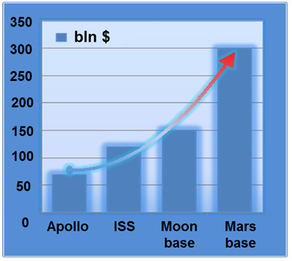
Figure 2.1. Comparison of estimated costs of implemented major space programs and future extraterrestrial long-term operation facilities
As we can see, the cost of implementing such projects is potentially comparable with the annual GDP of large countries. Even with account of the long period of creation and operation of the facilities (from several years to decades), the annual costs will be close to 10 billon USD. It is obvious that successful implementation of such projects – general tasks of humanity in effect – is only possible with wide integration of international efforts and resources, involvement of a multitude of state and private companies in this process, and simultaneous searching for ways to reduce the overall cost of the developments.
It should be noted that there is no internationally accepted generalizing name for the projects of creating in-space long-term operation facilities for cislunar space and lunar surface and, in the future, Mars and deep space exploration as yet. For convenience in this text they will be referred to using “In-space System” term, having in mind basically – In-space (Extraterrestrial) Long-Term Operation System.
This technical report deals only with one potential for In-space Systems development and operation cost reduction – harmonization of interfaces.
Conceptually, as applied to crewed and hybrid (combining automatic and crewed segments) In-space Systems, this potential can be illustrated by the following considerations.

2.1.1 IN-SPACE SYSTEMS features
Future crewed and hybrid (combining crewed and automatic segments) facilities for lunar space and lunar and martian surface exploration will have a number of characteristic features distinguishing them from other space projects and determining their creation and intended-use (operation) cost:
- In-space Systems will be formed phase by phase, during a long time (several years) – from the first “vanguard” components to the full complex;
- In-space Systems will include components that can operate independently of the final configuration of the facility in whole (e.g. takeoff/landing, power, transport, navigation, communication components);
- Having been created, In-space Systems will be in long-term service (more than 10 years), gradually changing. Components whose warrantee period has ended will be removed from service (possible replaced); new elements will be introduced;
- In-space Systems will need continuous support from Earth in terms of both remote technical support and direct supply with consumable resources, and regular crew rotation.

2.1.2 Potential benefits of interfaces harmonization
Analysis of the features of In-space Systems listed in 2.1.1 allows us to identify certain potentials for reducing their total cost through harmonization of interfaces. Some of them are as follows.
2.1.2.1. Harmonization of payload and transportation system interfaces
The phased creation of In-space Systems, the needs for resupply of resources and crew rotation require an injection system of sufficient energetics allowing launches of necessary intensity over no less than a decade. It is necessary to have space launch vehicles able to lift more than 60 t to low earth orbit (LEO) (to supply the In-space Systems with resources and deliver some automatic segments) and more than 100 t (for the crewed components of the In-space Systems) allowing two to three launches a year.
All the super heavy-lift injection systems (SHLIS) that have been in development so far are national projects, or national projects with involvement of private funds.
Actually no state has a SHLIS today. The USA have come to this goal closest of all.
Under the direction of NASA, the cooperation of companies Boeing, United Launch Alliance, Orbital ATK, Aerojet Rocketdyne is developing four modifications of the space launch vehicle SLS using the groundwork acquired in the Space Shuttle program. The first launch of SLS Block 1 (an unpiloted version designed to inject 98t of payload into LEO) is scheduled for 2020. It is planned in the future to modify it into a piloted version – Block 1В capable of placing 98t of payload in LEO and create a launch vehicle SLS Block 2 on its basis with a load-lifting capacity over 110 t (Figure 2.2).
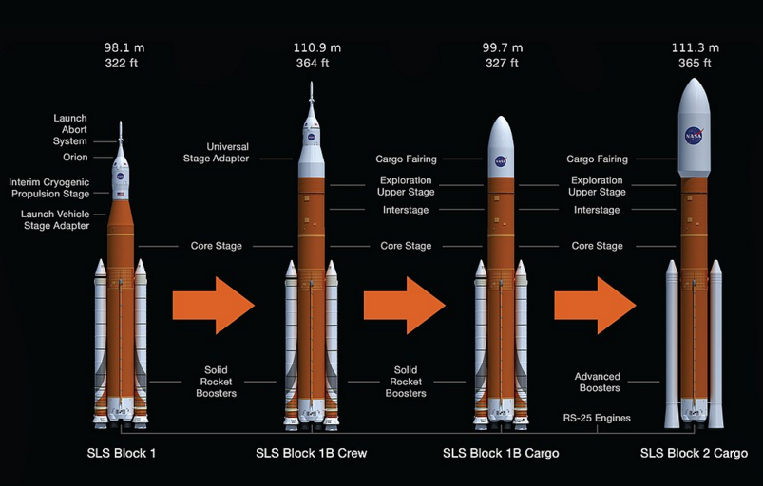
Figure 2.2. SLS launch vehicle (USA) product line.
NASA’s illustration
Moreover, today the USA possess an only space vehicle in the world capable to place about 68.3 t of payload in LEO – Falcon Heavy created by SpaceX (Figure 2.3).
Two successful launches of the Falcon Heavy have been done (the first one on February 6, 2018). The vehicle has unique characteristics allowing repeated use of the first and, potentially, the second stage. However, its energy capabilities are not sufficient for the creation of crewed In-space Systems and can only enable support of a near-Earth segment or deployment of robotic In-space Systems on the surface of the Moon or Mars.
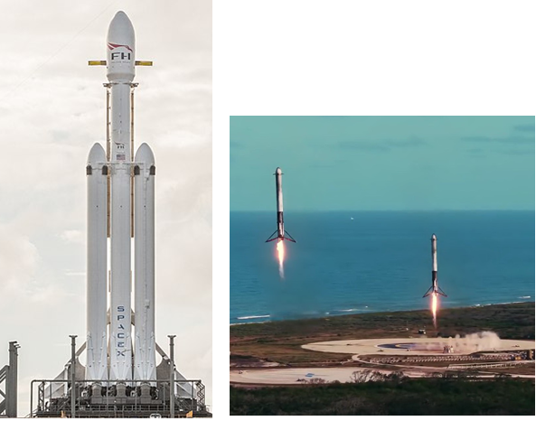
Figure 2.3. Falcon Heavy created by SpaceX USA).
Landing of two boosters of the Falcon Heavy launch vehicle’s first (“zero”) stage. SpaceX’s illustration
Since 2012, company Blue Origin in the USA has been developing a heavy reusable vehicle New Glenn (originally named Very Big Brother), whose first launch is planned for 2021. The vehicle’s stated load-lifting capacity is 90 t to LEO, 13.6 t to geostationary orbit. Its dimensions: height 99 m, diameter 7 m, fairing’s usable volume 458 m³. On the first stage should be installed 7 engines BE-4 – Figure 2.4.
Along with the launch vehicle New Glenn, Blue Origin is also developing its own reusable piloted vehicle and carrying out an intensive program of its field tests (Figure 2.5).
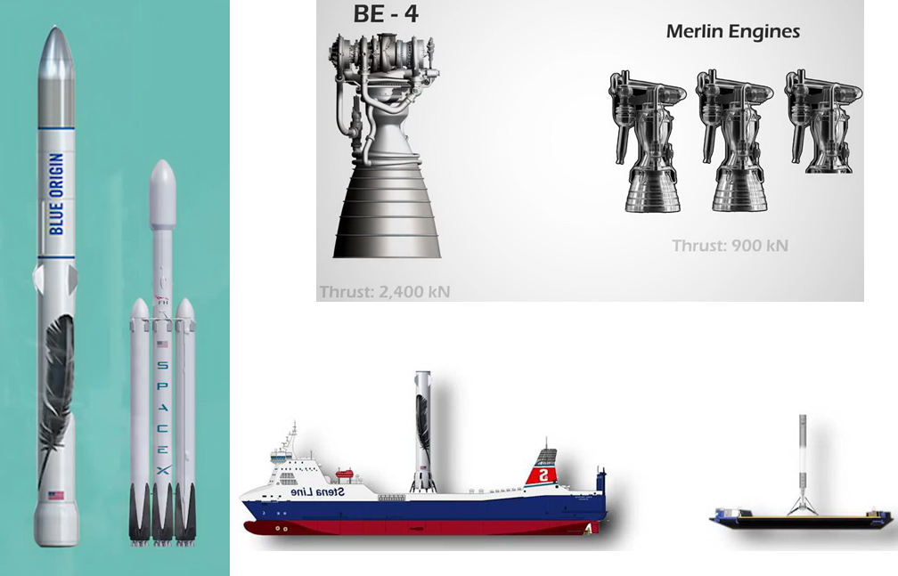
Figure 2.4. Visual comparison of New Glenn and Falcon Heavy, engines of the first stage, and landing platforms.
Blue Origin’s illustrations
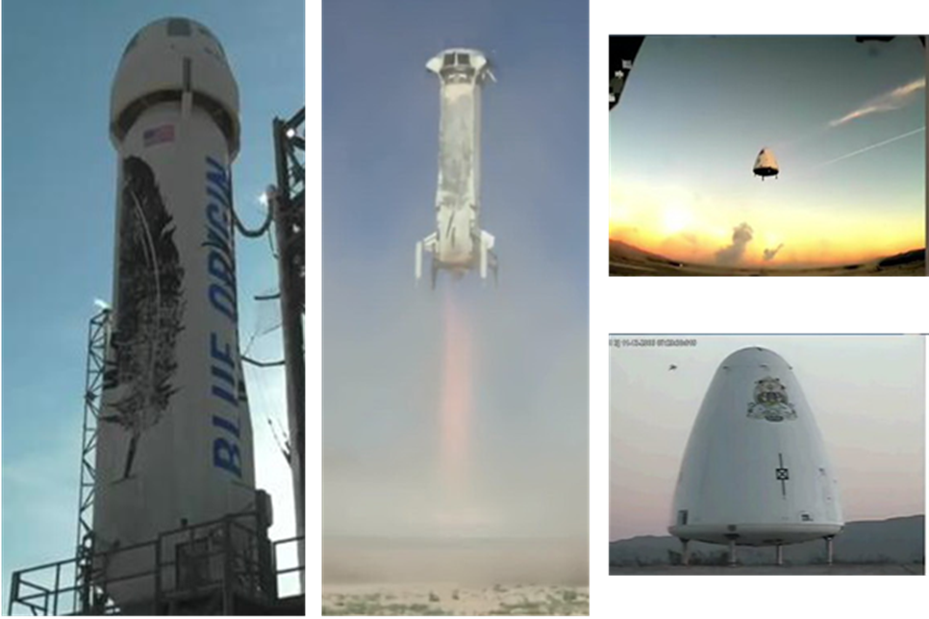
Figure 2.5. Field tests of landing systems of elements of the space launch vehicle and piloted vehicle carried out by Blue Origin
Blue Origin’s illustrations
In January 2019 Roscosmos (RF) declared the beginning of works for creation of a super heavy-lift (SHL) vehicle. The SHL launch vehicle in its initial configuration should inject 88 t into LEO, in the final configuration about 108 t (Figure 2.6). The vehicle has been named Yenisey.
 | Development test modification of the super heavy-lift launch vehicle. | Super heavy-lift launch vehicle (phase I). | Super heavy-lift launch vehicle (phase II).
 | CTV flyby of the Moon (2027). | CTV launch to polar AMSO (2028) | Launch to polar AMSO (2032-2035)
DM-type booster  Stage-II rocket pod with RD0124M  Stage-I rocket pod with RD0171M. | 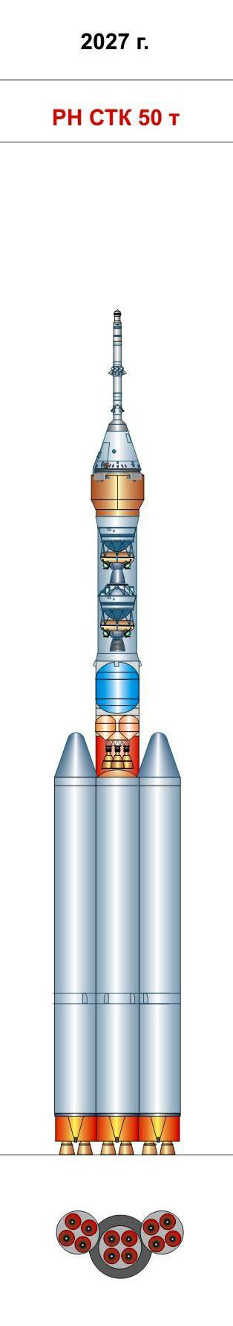 | 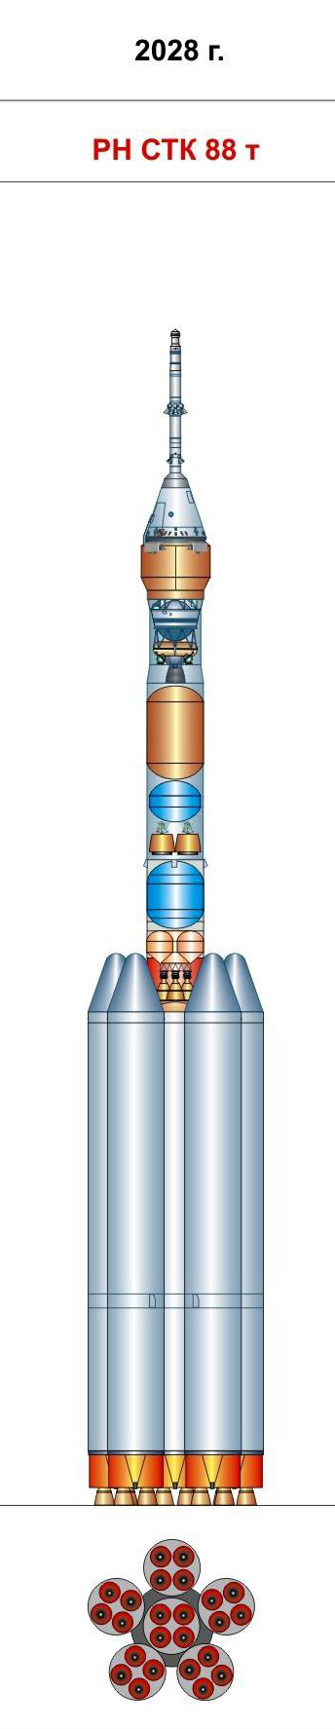  II rocket pod with RD0150M. | 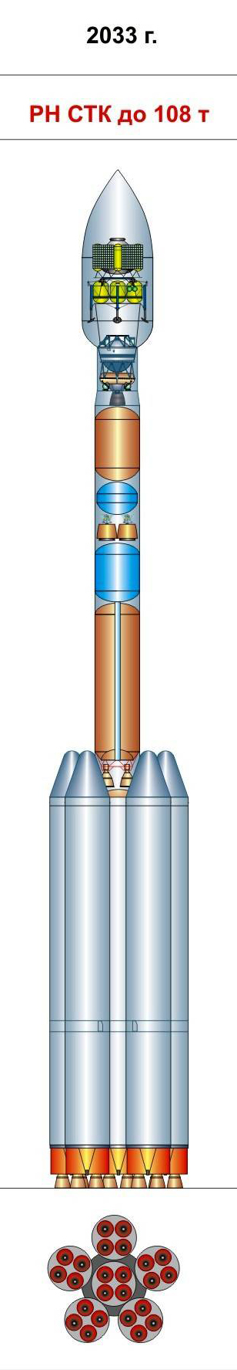
Spaceport | Vostochny | Vostochny | Vostochny
Lift-off mass, t | 1440 | 2800 | 2840
Load-lifting capacity, t | 50,0 | 88,0 | 108,0
Figure 2.6. SHL launch vehicle creation sequence, characteristics and dates for creation (RF)
Roscosmos’ illustration
The first launch of the SHL vehicle Yenisey (in 2027) should provide, as reported by TsNIImash [6], for the development testing of the crew transport vehicle (CTV) Federation (Figure 2.7) with a Moon flyby and return to Earth. The CTV should become, beginning from 2024-2025, the key element of the piloted flights performed by the RF and deliver crews to near-Earth orbital stations and future crewed In-space Systems in lunar space at the libration point L2 of the Moon-Earth system and directly to the Moon in case of deployment of a permanent Moon base.
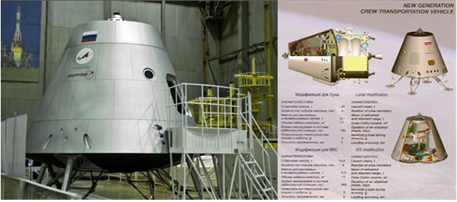
Figure 2.7. CTV Federation. RSC Energia’s Illustration
Potentially, by the end of the 2020th, the People’s Republic of China may become a possessor of In-space Systems. The PRC has not yet reported officially about its works on a super heavy-lift vehicle. But information of such works has appeared in the mass media [7] – launch vehicle Long March 9 (Changzheng-9) – Figure 2.8.
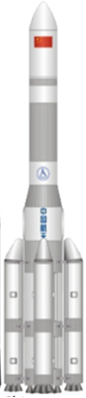 | Number of stages 2  Length (with the payload unit) 98-101m  Diameter 10m  Launch mass 4100000– 4150000 kg  Payload LEO: 130000 km GTO: 50 000 km
Figure 2.8. Long March 9 Launch vehicle (Changzheng-9).
The characteristics have been taken from open sources.
SHLIS possessors will be initiators of creating particular target In-space System s. At that, the projects will be maximally oriented to “loading” their own national cooperation of developers. However, as said above, the cost of creating and operating a full-fledged In-space Systems (except for the initial, vanguard development phase) requires resources whose diversion would be troublesome even for the economies of the USA and PRC, not to mention the RF. So international cooperation is inevitable.
On the other hand, space agencies of Europe, Japan, India, South Korea, Ukraine, countries whose own potential is insufficient for SHLIS creation, are able to make valuable contributions participating in the projects of the countries having SHLISs, in particular in the cooperation for creating target components of In-space System s.
Developers of any component of In-space Systems will from the outset face the problem of tailoring to the injection vehicle, and this, apart from the associated loads and mass and space limitations, will require mechanical and electrical interfaces to be mated and EMC and other problems to be solved.
Unification of requirements for payload and injection system integration interfaces will allow developers of In-space Systems components to avoid unnecessary repeated costs for tailoring to the injection vehicle both at the design stage and the ground development test stage.
2.1.2.2 Harmonization of In-space Systems` components interaction interfaces
Components of In-space Systems under development must interact with each other. Such interactions will be done through dissimilar interfaces. Component developers should be guided by the unified requirements for these interfaces, otherwise irrational tailoring costs and the necessity of introducing various transition components into the configuration of In-space Systems components reducing the target payload would be unavoidable.
There is also another important aspect of In-space Systems components interaction. The cost of fully autonomously working components is going to be much higher than that of a component created with account of the capabilities of other In-space Systems components and using them in its operation. Therefore, relatively independently functioning components must from the very beginning be developed with due regard to the ability of using resources of other components for the fulfilment of the target mission.
For example, for the fulfilment of the target mission, ascent/descent modules can be fully autonomous, independent of the In-space Systems, or can use the navigation and communication equipment of other components, the energy of a Moon or Mars base for a flyoff, the availability of rovers and lifting equipment, etc. Design of mutually complementary In-space Systems components requires deep harmonization of their interfaces.
2.1.2.3 Harmonization of interaction interfaces of In-space Systems of different developers
The long-lasting periods of In-space Systems deployment and operation will inevitably bring about a situation when other similar facilities with similar target purposes will be deployed in parallel. This is especially true for Moon exploration. This concerns both robotic In-space Systems and the alternative crewed facilities created by a different international cooperation (prospective programs of the USA, China, the RF).
Integration of similar developments into those complementing and developing each other would bring a much greater cumulative effect for the people of Earth than going through the already mastered phases or phases of the same-type by each national developer separately, and would significantly reduce the total costs. It is obvious that this potential can be realized only if interfaces of the alternative projects are deeply harmonized.
2.1.2.4 Harmonization of information exchange and support cargo traffic interfaces
The need for continuous support of In-space Systems from Earth also requires the harmonization of interfaces of useful cargo traffic and information exchange equipment. This is especially true for crewed In-space Systems.
A good example is the experience of the ISS where the compensating material resource for the ISS is provided by cargo spacecraft of two countries: Progress-TM (RF), Space Shuttle (in the initial phase) and Cygnus (USA), with unification of mass-size characteristics and integration interfaces of cargos and resources (water, compressed gases, hygiene necessities, food products, etc.).
2.1.2.5 Harmonization of survivability and safety support equipment interfaces
The complexity and the lack of practical experience of supporting In-space Systems require special consideration of survivability and safety during their development. For this purpose, the whole support architecture must from the outset be constructed as a complementary mechanism, which, in its turn, cannot be implemented without harmonization of interfaces. There must not be a situation when existing in parallel one-type-purpose facilities are unable to give mutual support or when they have non-complementary safety support equipment.

2.2 Factors hampering solving of interfaces harmonization ISSUE
With the general obviousness of the benefits of the harmonization of In-space Systems interfaces and their components, in today’s reality it confronts a multitude of obstacles in the way of its realization. Among them, two main blocks can be marked out:
- Political and legal, international, national, corporate;
- Technical.

2.2.1 Political and legal, international, national, corporate
Despite the need for international consolidation of means and resources for the creation of In-space Systems for exploration of lunar space, the surface of the Moon and, in a more remote future, Mars, the real implementation of such an integration encounters political and legal restrictions.
The leadership in the development of projects of this kind, as was said above, will undoubtedly belong to the countries that possess or are close to possessing super heavy-lift injection vehicles (the USA, the RF, and the PRC). They base the strategy of international cooperation on their own national interests. These cover both the attainment of unquestionable advantage in the “space race” and the steady dynamic development of their own real sectors. Not only with respect to rocket and space technologies but the economy in whole, through the multiplier of orders, restrictions for expansion of rocket technologies to competing countries, etc.
Closed international pools are formed in a natural way, wherein companies of associations of other countries are accepted very unwillingly, and even if they are accepted then only for secondary activities. The leader of a formed pool in fact determines conceptual solutions that are often advantageous to their own project and “own” cooperation but are far from optimal solutions for the declared target tasks of the facilities being created, especially in the long-term perspective.
Legal mechanisms are generally built on an international bilateral basis: leader – project participant.
A clear illustration of the above thesis is the situation that formed around a much simpler target mission than exploration of lunar space, the Moon and Mars – a crewed near-Earth space station.
The implementation period of two independent of each other national projects Salyut-Mir (USSR, RF) and Spacelab (USA) limited the possibility of involving wide international cooperation in solving their target tasks. One of the main “decelerating” factors was the military application character of these national projects.
It was only when the both leaders of the space race created the ISS that there appeared the possibility to expand the cooperation and build a facility much more answering the common earth tasks. The involvement of other “players” (European, Canadian, Japan, South-Korean and other space agencies) has enabled in a relatively short time to realize original scientific and application projects and test new technologies.
On the other hand the PRC, having not become a participant of the ISS creation, today, at the national level, step by step, has to go once again through the phases of creating an orbital crewed space station that were passed by the USSR, the RF and the USA, and this, in the final accounting for humanity in general, is increasing the total costs of solving this task.
Far costlier will be the In-space Systems projects addressed in this technical reference, if they are implemented separately in parallel by several pools of the main “players”. And this is the situation which is developing today. Conceptions of the corresponding national programs of the USA, China and the RF clearly repeat the “autonomy” precedent of the large-scale space programs of the 20th century. Ultimately, this is going to substantially increase their implementation time and will result in irrational use of the limited earth resources due to repeating the steps of the same type by each of the players.
Unfortunately there are no effective mechanisms today to solve the problem of pooling resources for target tasks of such a level. The existing attempts at international coordination, made mainly by the USA, pursue manifestly national and political interests – to increase the leadership, leaving just auxiliary functions for others. A relevant example of this kind is the cooperation created by the USA around the Lunar Orbital Platform–Gateway project, which shows a rollback even from the USA-RF cooperation level achieved for the ISS.
A big hindrance for extended international cooperation is that a major share of technological solutions in the creation of similar facilities remains in the sphere of double-purpose technologies. Whole systems of national political and legal barriers are acting against spreading of such technologies. These systems are built not only in interstate relations but inside countries as well, between the civil and the military sector.
At the level of private companies, the following group of restrictions is acting in connection with the corporate protection of sensitive technical and economic information, intellectual property protection. Corporations, to retain competitive advantages, carefully guard their advanced engineering solutions, know-how, protect technologies and specimens with patents.

2.2.2 Technical
The technical factors that hamper harmonization of interfaces during In-space Systems creation, particularly with involvement of wide international cooperation, include the following:
2.2.2.1 Uniqueness of transportation vehicles and configuration of injected In-space Systems components
Every super heavy-lift injection vehicle created by space race leaders is unique. The interfaces integrating a specific launch vehicle with a payload to be injected bear the “impress” of the country-manufacturer, which impedes, if not makes impossible, the use of an alternative injection vehicle. The problem is not only about mass-space limitations and parameters of associated loads but also about such particular interfaces as electrical (including information and control protocols), pneumohydraulic, mechanical, maintenance of required temperature and humidity conditions and cleanliness in the payload fairing volume, bonding, etc.
A practical solution to this problem for attracting wide international cooperation to the creation of In-space Systems components can be unification of SHLISs under creation at the main interfaces with the payload.
There is certain, continuously improving experience in the world with unification of launch-vehicle and payload interfaces, in particular, when commercial launch services are sold to launch different-purpose spacecraft. An example can be the set of International Standards (IS) ISO 14303 (released in 2002 and revised in 2018), which, together with ISO 15863 and ISO 17401, describes a process by which the information on interfaces of the launch vehicle and payload (spacecraft) is tied together, and unification of requirements for payload attachment adapters.
However, such approach can hardly be realized exactly for the reason of the engineering uniqueness of every SHLIS.
If In-space Systems development is being conducted exclusively within a national project (for a particular launch vehicle), then the tasks of integration will be solved in the unified field of the existing technical regulations and standards of the state, tried-and-true design solutions, mostly on the existing production and component base with account of the existing ground infrastructure (capabilities of transport means, process areas and buildings of spaceports, tracking stations.
2.2.2.2 Complexity of integrating different-target-purpose components of In-space Systems into a completesystem
It is obvious that In-space Systems components interaction interfaces should be maximally universal and complementary to enhance survivability of the facility in whole and reduce the costs of its long-term service.
Thus, potentially effective maybe the introduction of the following items into multi-component In-space Systems :
– Unified universal inter-component (inter-module) mating devices (as to dimensions, joining mechanics, electro-pneumatic lines);
– Crew life support systems standardized in target parameters (air composition, operating pressure, water quality, etc.) with standardized interfaces for integration with resupply delivery, power supply, waste disposal means;
– Standardized-in-interfaces means allowing the human to work in the environment outside the habitable envelopes of the In-space Systems and ensuring the operation of a certain set of the equipment allowing the human to come out onto the surface (airlocking equipment, spacesuits);
– Specific methods to form meteorite and radiation protection or at least observe the agreed boundary conditions which such protection must provide for with account of its repairability;
– Standardized principles to form control, data flow arrangement, communication, telemetry and navigation systems;
– In-space Systems on-surface-deployment means having mechanical interfaces that are compatible or easily adaptable to different typical sizes (this refers to the line of lifting and transport equipment for removal of modules from landing stages, delivery to the assembly site, assembly).
A number of other items.
Today developers of future In-space Systems are guided by their own national or corporate practice when making technical decisions on most of the mentioned interfaces.
In case of wide international cooperation involved in In-space Systems development, the harmonization of In-space Systems components interaction interfaces is much more difficult to achieve. The international cooperation in this direction is at its initial stage (see Section 3).
2.2.2.3 Resupply of consumable resources for In-space Systems. Establishment of general support architecture for simultaneously operating In-space Systems
Every facility will need certain resource-replenishing cargo traffic from Earth, at least in the first phases (reaching the 100% In-space Systems self-sustainability at the present level of technologies can only be real for automatic facilities for a limited period. At that, a considerable portion of this cargo traffic (up to 60-80 %) will be rocket propellant components, water, compressed gases, and food products. The universal approach to organizing the necessary cargo traffic should include the harmonization of mass-size characteristics of cargos, receiving/issuing interfaces, procedures.
Today the works on harmonization in this direction, because of the conceptual uncertainty of In-space Systems configuration, are based mainly on the ISS experience (see Section 3).
Even less attention is given to interfaces harmonization for creation of general support architecture for In-space Systems having the same types of tasks but being developed by different “pools”. A situation is potentially formed when facilities existing in parallel will not be able to render mutual support or use ground support structures of other facilities due to incompatibilities of interfaces.
2.2.2.4 Differences in technical standards and regulations
It should be noted that a considerable part of problems that lead to adopting incompatible engineering solutions when developing In-space Systems projects occur because of the differences in the bases of technical standards and regulations of the space race leaders. This incompatibility cannot be eliminated solely by the mutual rule-making activity, because it roots in the differences of the achieved level of manufacturing technology and access to the manufacturing and component base.

Analysis of existing and future developments in terms of compatibility of interfaces

3.1 Brief overview of current status of developments
Since the start of the 2000s, attempts have been made to systemize all the promising works in the directions of lunar space, Moon and Mars, and deep space exploration. The International Space Exploration Coordination Group (ISECG) publishes an updatable document, The Global Exploration Roadmap (GER). Its third edition [8] came out early in 2018. Figure 3.1 shows a condensed form of the GER forecast.
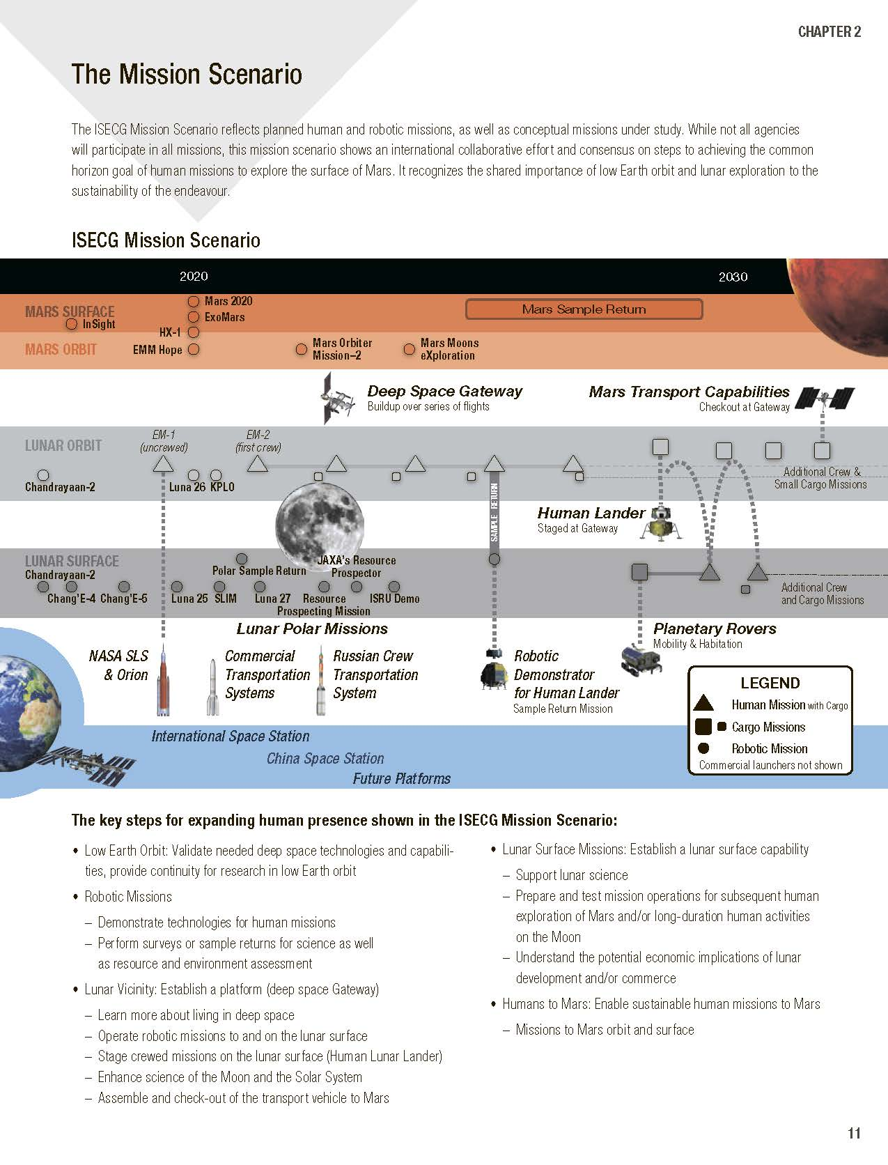
Figure 3.1. Illustration from the Global Exploration Roadmap document, 2018
The GER is formed based on the synthesis of public data about international projects being developed in this sphere and the corresponding national and corporate programs.
A diagram of long-term research plans for lunar space and Moon exploration placed on the NASA website (Figure 3.2) can be an example of such information.
Based on the GER, we will give a brief overview of the current state of the developments.
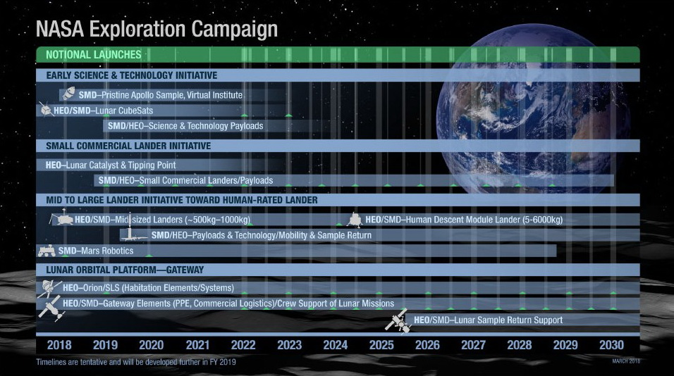
Figure 3.2. Long-term research plans of NASA for lunar space and Moon exploration
NASA’s illustration

3.1.1. Super heavy-lift TRANSPORTATION systems
The ISECG has forecasted that by approximately 2025, at least three SHLISs will be ready to inject In-space Systems components: SLS (NASA), Falcon Heavy (commercial) – both of the USA, and SHL (RF), which were mentioned in subsection 2.1.2. The first launch of SLS should take place in 2020, SHL in 2027. Space X has already launched Falcon Heavy.
Among those not mentioned specifically in the GER, intensive works are under way for a completely original brainchild of Space X – a two-stage SHLIS Starship and Super Heavy, earlier denoted BFR (Figure 3.3).
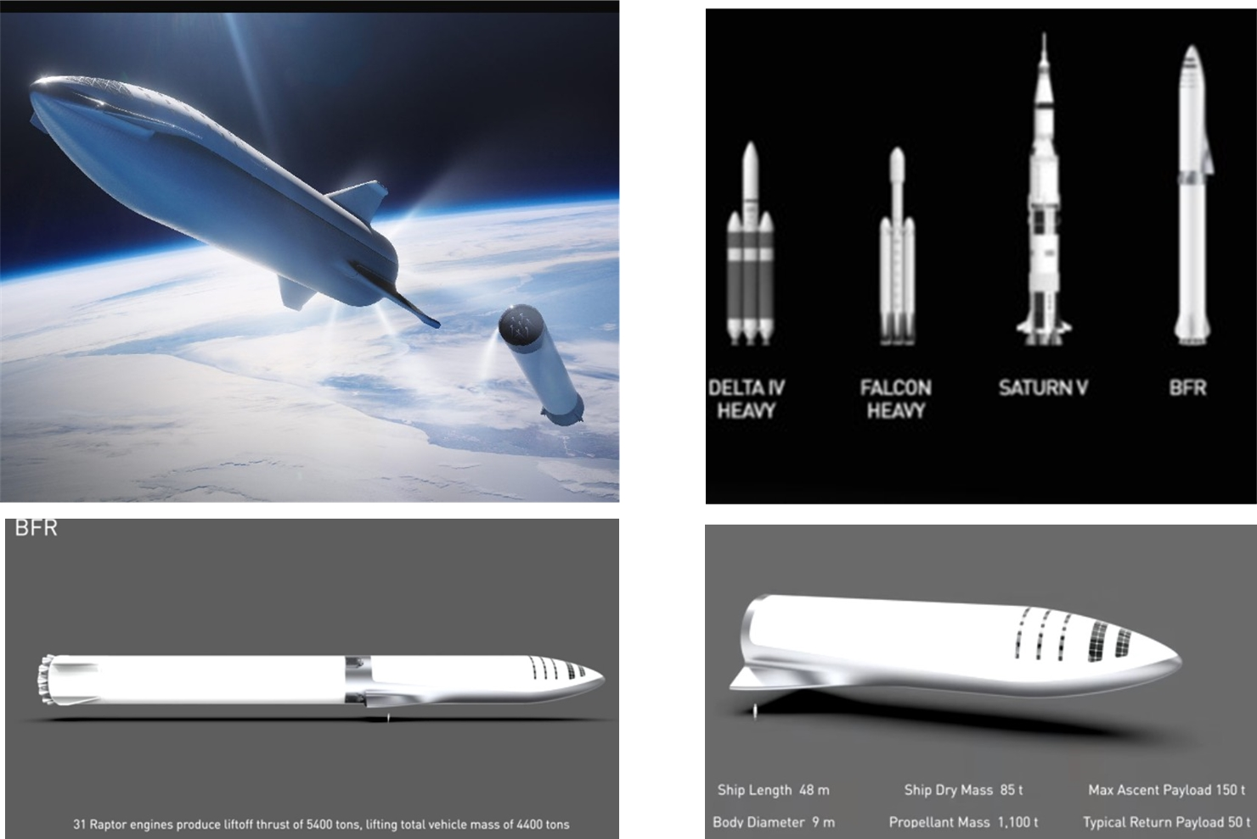
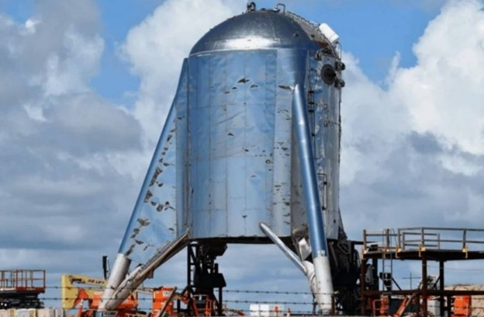
Figure 3.3. Starship and Super Heavy (BFR) SHLIS project and testing of Starhopper – a part of Starship
Space X’s illustration

3.1.2. projects ON DEVELOPMENT OF IN-SPACE SYSTEMS
Without referencing to a particular SHLIS, the lunar space and Moon exploration concepts under development have common features and envision, in one form or another, the creation of the following In-space Systems:
- On the surface of the Moon:
- A permanently operating robotic, crewed, or hybrid base;
- In lunar space:
- A permanently operating transit crewed station (for conceptions requiring its use);
- Scientific and service facilities: selenographic, navigational, systems for communication of circumlunar objects with objects on the Moon and Earth.
The last-named can be created not only to have an independent target function but also to be part of larger In-space Systems – circumlunar stations and/or lunar bases – to support their functioning. It can be predicted that similar approaches will be implemented in a remote future for Mars exploration.
GER-2018 mentions only one project, which could be strictly referred to as In-space Systems: Deep Space Gateway and Transport (DSG&T), the groundwork of which should be laid by creating a circumlunar orbital station – Lunar Orbital Platform-Gateway (LOP-G) (Figures 3.4 and 3.5).
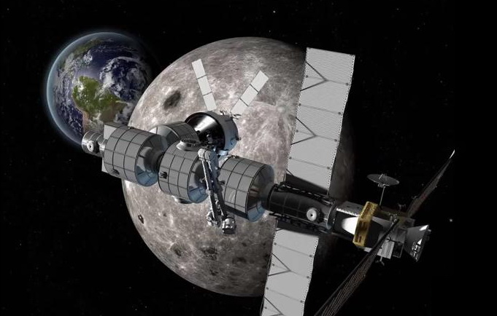
Figure 3.4 Circumlunar orbital station – Lunar Orbital Platform-
Gateway (LOP-G).
Boeing’s illustration.

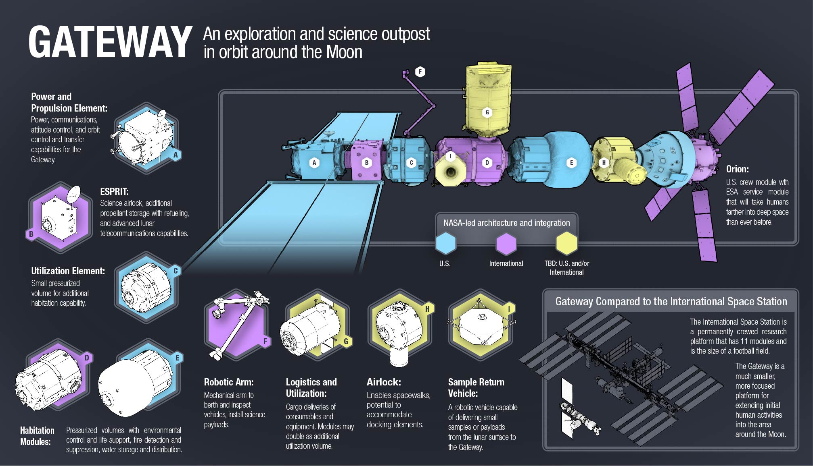
Figure 3.6 Purpose of LOP-G modules and where they belong.
NASA’s illustration.
In general, the DSG&T project concept envisages [9] the creation of a base orbital station LOP-G until the end of 2025, consisting of three objects:
- Power and propulsion module (Power and Propulsion Platform – PPP);
- Habitation module to be used for the initial LOP-G assembly (U.S. Utilization Module);
- Module for resupply of resources of LOP-G (refueling, etc.) and for communication (European System Providing Refueling, Infrastructure and Telecommunications – ESPRIT).
Later on (in 2025-2027), instead of the U.S. Utilization Module, two habitation modules will be attached to LOP-G:
- U.S. Habitat;
- International Partner Habitat.
In the course of the DSG&T project development, at LOP-G will arrive and complement it or use it as a transit point:
- Different-purpose logistic modules, including interorbital tugs and Moon landers (generally denoted Gateway Logistics Modules);
- Airlock module for work with logistic modules, spacewalk – Gateway Airlock Module;
- Deep space transport vehicle – Deep Space Transport (2029).
A cooperation of the main developers of LOP-G has been announced – they are the ISS partners: NASA, Roscosmos, ESA, JAXA, and Canadian Space Agency.
The spacecraft Orion (whose main developer is Lockheed Martin), consisting of two modules – crew and service (Figure 3.7 and Table 3.1), is meant to be the base crewed space vehicle to deliver crews during the creation and operation of LOP-G.
Table 3.1 – Stated technical characteristics of the crewed spacecraft Orion
Technical characteristics | Overall | Crew module | Service module
Height, m | 8.5 | 3.3 | 5
Diameter, m | 5 | 5 | 4.8
Volume, m³ | 19.56 | 8.95
Lift-off mass, kg |  | 8900 | 3700 (dry)
Crew | 4
Autonomous flight duration, days:
- Powered flight | 21
- Coast flight | 210

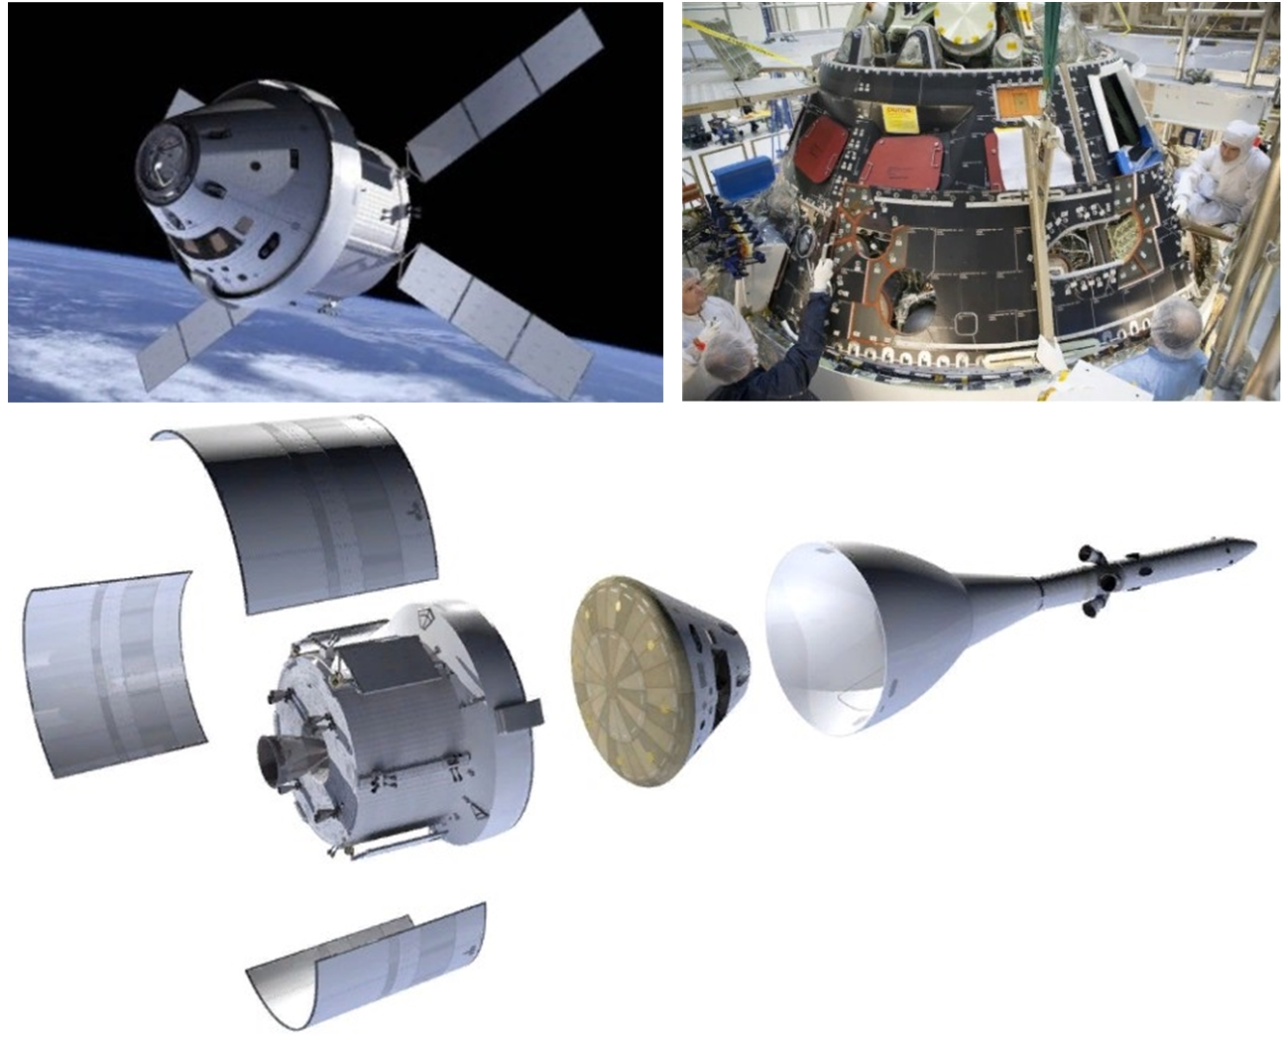
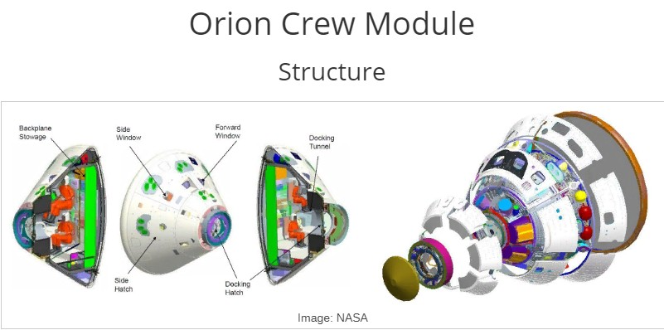
Figure 3.7 Crewed spacecraft Orion.
NASA’s illustration
In general the plan of crewed flights during the creation of LOP-G is presented both in GER-2018 (Figure 3.1, 6 marked launches, EM marks) and in the scheme below in Figure 3.8. Figure 3.8 also shows a sequence of launching the cargo version of SLS to deliver LOP-G modules.

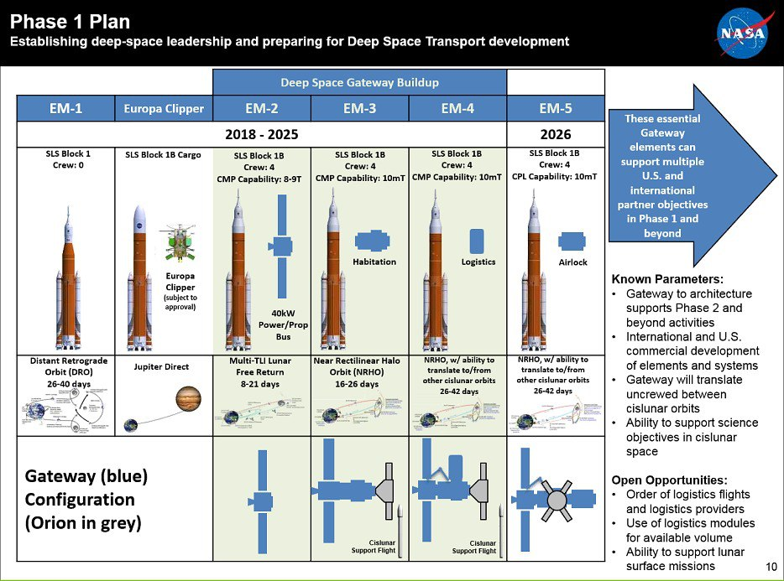
Figure 3.8 Planned launches of the SLS SHLIS during the creation of LOP-G.
NASA’s illustration
It should be noted that the LOP-G conception has lately been undergoing serious critical reconsideration. At the beginning of 2019, US President D. Trump assigned a task for NASA to renew the crewed presence of the USA on the Moon by as early as 2024. The conception has been named Artemis. This circumstance may substantially change the Global Exploration Roadmap.
After the USA declared that the LOP-G management and configuration would be the exclusive responsibility of the US party, Roscosmos notified of their refusal to take part in the project. At the same time, in February 2019, the RF updated its own conception of In-space Systems development based on the Yenisey SHL launch vehicle and outlined the objectives of crewed lunar expeditions [10]:
- First crewed flight with landing on the Moon and performing works according to the tasks of the Russian Academy of Sciences (2031);
- Delivery and approbation of a heavy crewed lunar rover (2032);
- Delivery of robotic complexes to the Moon’s surface and their testing (2033);
- Beginning of the delivery of modules to the Moon and the construction of a lunar base (2034);
- Construction of a lunar base (starting in 2035).
Every expedition will be implemented through a paired launch of two SHL launch vehicles: the first launch vehicle will bring a crewed spacecraft into near-Earth orbit, the second one will serve for the flight to the Moon, landing, and subsequent launch from the Moon and flight to Earth or to near-Earth orbit.
The SHL launch vehicle production rate should provide for at least 2 launches a year (note that SLS is planned to be launched just once a year).
The conception of the Chinese national program for creation of circumlunar or lunar facilities that could be considered as large In-space Systems, has not been publicized yet.

3.1.3 In-Space systems` components
In the future In-space Systems designs for lunar space and Moon exploration, regardless of their deployment concept, can be marked out the following functionally components of the same type:
- Baseline crewed vehicles;
- Logistic modules:
- Ascent/descent logistic modules of crewed and/or cargo design;
- Interorbital tugs (near-Earth orbit – circumlunar orbit);
- Specialized modules (power, habitation, airlock, docking, scientific, etc.) with a capability of integrating them into a unified complex;
- Communication and navigation systems (of orbital and/or surface deployment design);
- Different-purpose transport rovers, including heavy crewed ones;
- Power units and modules;
- Different-purpose robotic systems (manipulators, auxiliary technological, anthropomorphic);
- Research stationary and mobile laboratories;
- Load-lifting, drilling-and-exploring, and building mechanisms;
- And a number of other components.
Among the above listed, the most important as well as most financially burdensome are base crewed vehicles, ascent/descent and interorbital logistic modules, and power units.
The GER-2018 forecast mentions, apart from the base crewed vehicle, the creation of a crewed ascent/descent lander and a heavy crewed rover.
Information on the base crewed vehicles Orion (USA) and CTV (RF), which have been under development for a long time, is given above.
Now, briefly about the ongoing developments of heavy ascent/descent modules capable to support crewed expeditions to the Moon, first of all those intended for injection by SLS.
The most advanced development lying along the general conception of creating LOP-G has been offered by Lockheed Martin, which is a natural result of its many years’ work on the Orion spacecraft. Its lunar lander (Figure 3.9) was presented at the 69th International Astronautical Congress in Germany. It is expected to use it many times in shuttle flights from LOP-G to the Moon’s surface and back, with refueling at LOP-G. The crewed version of the lander should be able to land 4 crew members and deliver up to 1000 kg of cargo. The lander’s life support systems should be able to provide for crew needs for up to 14 days.
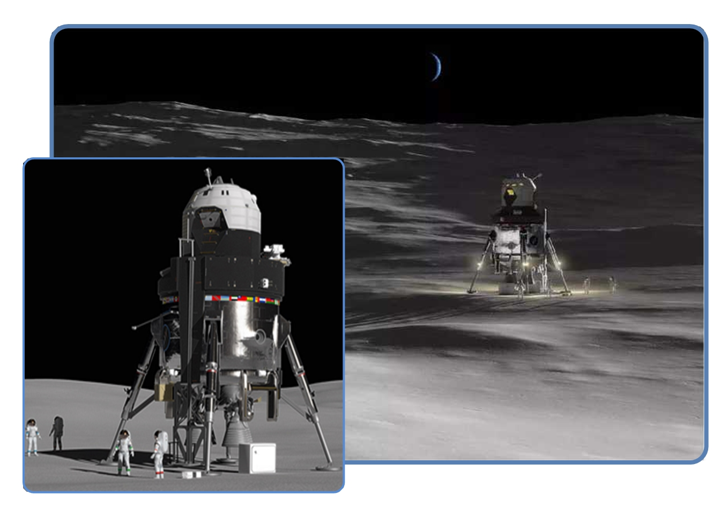
Figure 3.9. Lunar lander of Lockheed Martin
Lockheed Martin’s illustration
Also the prospect of modifying the lander for it to be filled with liquid oxygen and hydrogen obtained from the Moon’s water is foreseen.
In the design of its lander, according to Tony Antonelli, director of advanced programs at Lockheed Martin, the company will use the Orion spacecraft experience. The project implementation cost, according to estimates, may exceed 15 billion dollars.
NASA has not yet officially designated the lunar lander’s developer, allowing other US private companies to offer their designs.
This year, a presentation took place of the concept and a demonstration mockup of Blue Origin’s Blue Moon lander (Figure 3.10). The vehicle is being designed to be injected not only by SLS but also by their own SHLIS - New Glenn, as well as using the Atlas V launch vehicle. The lander is also reported as being designed in the tideway of the general DSG&T concept but as a universal single-use platform capable of delivering about 4500 kg of cargo (including a crewed vehicle) to the Moon. Unlike Lockheed Martin’s lander, the direct interaction of Blue Moon with LOP-G (docking, refueling) is not foreseen. Blue Moon’s propulsion system should operate on a pair of oxygen and methane.
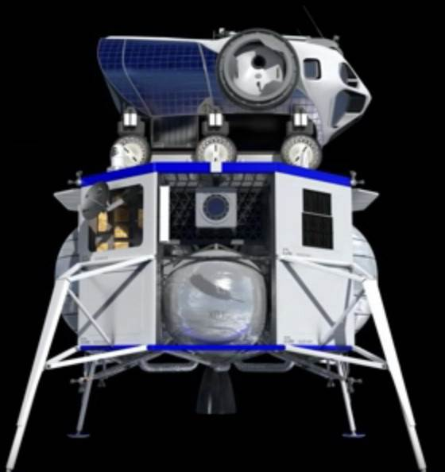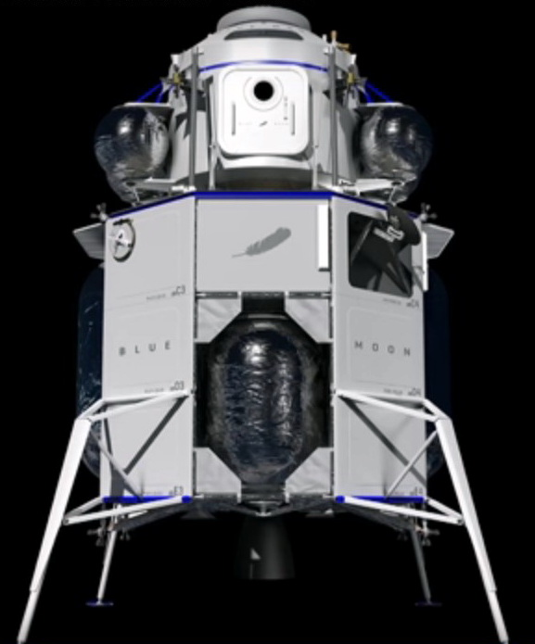
Figure 3.10. Blue Moon – lunar module of Blue Origin.
Blue Origin’s illustration
Besides the mentioned modules, heavy lunar landers are being developed in the RF (for Angara-A5B and SHL) and in the PRC. Yuzhnoye SDO (Ukraine) is also developing a conceptual design for a reusable lunar lander capable of delivering up to 8000 kg of payload to the Moon.
A basically different approach to solving the Earth-Moon-Earth cargo traffic problem is shown by Space X’s revolutionary conception, which tries to combine a base crewed vehicle, an interorbital tug and an ascent/descent lander into one reusable vehicle – Starship. To implement this project, it is necessary to solve a great number of engineering and technological tasks, among them the most complex being:
- Aerodynamic deceleration (multiple!) of an object 9m in diameter and 48m long from speeds close to the second-cosmic velocity;
- Months-long thermostating of tanks with hundreds of tons of cryogenic propellant components in flight and during stay on the lunar surface, without significant losses;
- Filling Starship with cryogenic components in near-Earth orbit;
- Need for the Super Heavy first stage having an absolutely unique load-lifting capacity (the stated lift-off mass of the bundle of Super Heavy and Starship is 4400 ton);
- Starship power supply and life support.
Whether such an idea is viable in principle – the future will show.
Large arrays of information are available on the conceptual and practical developments of the other above mentioned In-space Systems components, but even their brief overview would go beyond acceptable limits of a report on interfaces compatibility problems, so this information is not given herein.
Summarizing, it must be mentioned that the creation of In-space Systems as full-fledged facilities, as well as the creation of individual In-space Systems components is going to be preceded by quite a long preparatory robotic phase. This phase will be needed not only for verification of technological solutions but also for completion of a number of scientific investigations (of the ground, radiation, presence of bound water, etc.), for the final justification of the selection of future Moon base deployment areas, and for some preparatory operations.
A project HERACLES (ESA) (Figure 3.11), which is based on the DSG&T conception, can serve as an example of this approach.
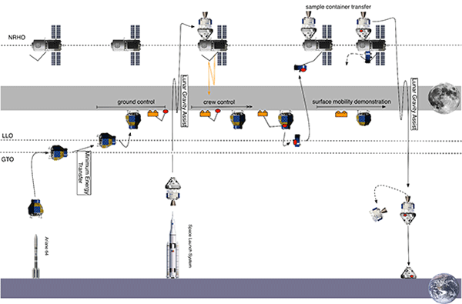
Figure 3.11. Scheme of implementing HERACLES Project (ESA) – robotic In-space Systems.
Robotic missions are much less expensive and can be carried out as independent research programs by, among others, countries having no SHLIS and/or by a cooperation of commercial companies, being part of the common conception of In-space Systems creation.
Examples of this approach are the automatic lunar missions: joint missions of the RF and the ESA (Figure 3.12), national missions of the PRC, Japan, and India; martian: ExoMars and Mars-2023 based on the existing injection vehicles, which are quite feasible within the periods outlined in GER-2018.
NASA, within the implementation of its own program CLPS (Commercial Lunar Payload Services), has selected 9 companies that are called on to solve the pressing scientific and technological problems for the creation of large In-space Systems in the period of 2019 to 2029 using small (10…20 kg payload) landing stages and low-orbiting circumlunar vehicles. These companies have been announced to compete for contracts totaling $2.6 billion [11].
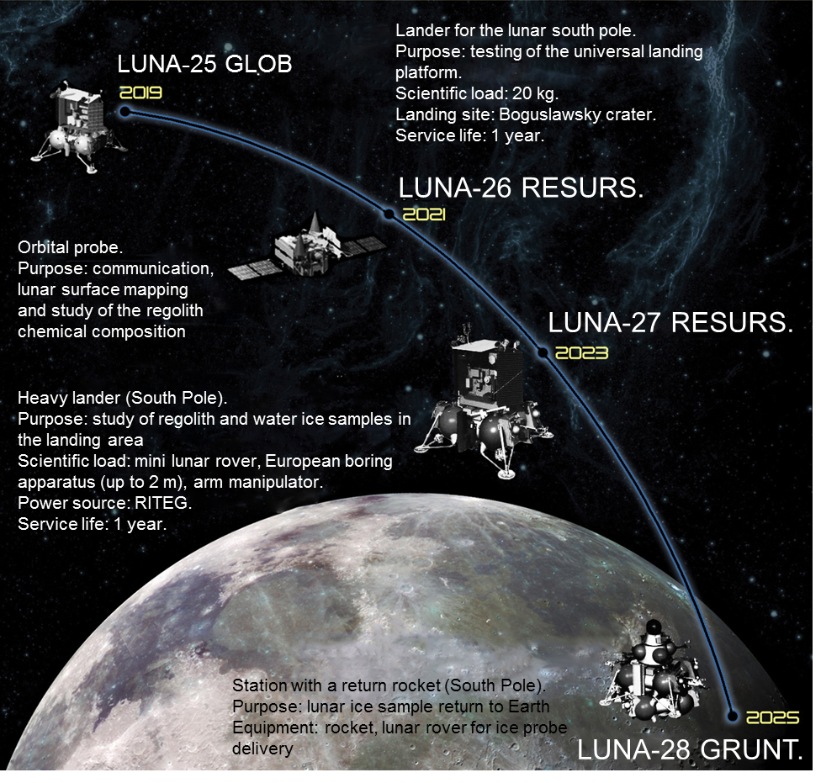
Figure 3.12. Joint lunar missions Luna-25÷28 (RF, ESA)
All these projects are relatively short-term, belong to the facilities of the MVA sphere, and undoubtedly are the necessary interim phase in creating crewed and hybrid In-space Systems.

Degree of using potential of interfaces harmonization in on-going developments
There is an important question: How much are the potential advantages of interfaces harmonization used in the ongoing developments of In-space Systems and their components? In other words, to which extent are the potentials discussed in 2.1.2 implemented?
Because of the contradictory character and insufficient volume of public data, it is not currently possible to conduct a complete technical quality analysis to answer this question.
Let us just note certain general regular patterns, discussing them in the sequence of the potential advantages of interfaces harmonization in subsection 2.1.2.

3.2.1 Compatibility of payload and transportation system interfaces
The need for the maximum use of SHLIS energy capabilities compels the developers of the main components of future In-space Systems (base crewed vehicles and ascent/descent modules) to structurally “bind” them only to a particular injection vehicle. To this also force the needs for creating specific conditions for PL prelaunch processing at a unique SHLIS launch site, including the arrangement of checking and filling equipment, and for designing the PL’s structure and systems with account of PL prelaunch processing technology.
There is no available information of any attempts to integrate the interfaces of the most advanced in their development base crewed vehicles (Orion and CTV) and ascent/descent modules with different SHLISs. The political factors, first of all the consideration of the human return to the Moon and Moon exploration as indicators of national prestige and technological superiority, are blocking the quite reasonable, from the universal point of view, opportunities of cooperation in solving technical problems. Today it is difficult to imagine the Orion developers conducting a coordinated work with the creators of the SHL launch vehicle or orienting themselves to the prospects of Changzheng-9 or vice versa. A similar situation is with the crewed lunar landers.
It has to be stated that, just as was the case in the middle of the last century, national developers overcome the numerous arising technical problems on their own, each time solving the same problems, repeating the same type mistakes, making huge investments into manufacturing technologies and the development and refinement of design solutions.
The USA, after all, makes efforts to organize international and state-private technical cooperation when it comes to less expensive components of future In-space Systems (specialized different-purpose modules, robotic systems, and a number of others). In particular, the LOP-G creators, as follows from Figure 3.6, have marked out a number of specialized modules to be developed by partners. It is obvious that participation in such a development will, in the first place, involve solving the problems of matching PL and carrier (SLS) interfaces.
As for the more remote in time creation and potential deployment of In-space Systems components such as lunar base modules and equipment, the problems of harmonizing their interfaces with SHLISs and ascent/descent landers from not their pool, they have not yet been discussed at practical level.

3.2.2 Compatibility of in-space systemS interfaces
The progress here is more noticeable because, as follows from our brief overview, DSG&T is in fact the only In-space Systemsproject that is gathering pace, whose only integrator is NASA. The latter circumstance, as noted in paragraphs 2.2.1.1 and 2.2.1.2, makes it possible early in the development of specialized modules to conduct a unified technical policy about their interaction. First of all with respect to docking and air-locking equipment, life support system parameters, electrical and electromagnetic compatibility, communication and navigation facilities compatibility. The similarity of the technical tasks set for LOP-G and ISS enables to widely use proven approaches.
It is obvious that in alternative projects, in the process of implementing the Russian/Chinese lunar programs, a similar situation is formed about the harmonization of the interfaces of interaction between modules – a single integrator, and a unified but their own technical policy with partial borrowings of ISS creation experience.
There is a separate question: will this technical policy be defined rationally with respect to the strategic purpose of humanity – consolidation of its presence on the Moon and in deep space? Or will it be only based on the national benefits of the moment?
A positive example of the attempts to come to a mutually acceptable solution of one of the key problems – compatibility of rendezvous and docking facilities – is the work for standardization of this process and the necessary hardware by ISS partners, which will be described in detail in section 4.

3.2.3 Compatibility of interfaces of IN-SPACE SYSTEMs of different developers
It is inevitable that several In-space Systems are going to exist in parallel in the future. Not only because of the national prestige but also due to an objective cause – the inevitable separation of particular functional tasks and specialization of In-space Systems (science, seleno-reconnaissance, mining, production of propellant components, etc.) in the future.
The possibility of achieving a synergetic result of their activities for the people of Earth will, to a great extent, depend on the ability of In-space Systems of different developers to interact directly with each other.
For example, there should not be situations when, in order to solve navigational tasks, several systems of the same type are deployed around the Moon each serving only the needs of their own In-space Systems (lunar base), or power units, water storages, rovers, load-lifting and building mechanisms with incompatible interfaces are deployed. A particularly unacceptable situation is when auxiliary facilities for the accurate landing of landers and facilities for the rendezvous and docking with orbital objects are incompatible.
This potential of benefits from interfaces harmonization is of a remotely futuristic character and therefore is on the remote periphery of interests of the modern creators of In-space Systems. Its actuality will appear and grow with the simultaneous implementation of alternative projects.

3.2.4 Compatibility of information exchange interfaces
The sphere of communication facilities compatibility and data processing facilities compatibility shows the most noticeable progress of international and corporate cooperation in harmonization of interfaces. The progress has to a large extent been achieved by the positive experience of cooperation in this sphere of the participants of the currently single working In-space Systems – ISS – and by the proven technologies used on Earth.

3.2.5 COMPATIBILITY OF SUPPORT OF CARGO TRAFFIC, SURVIVABILITY AND SAFETY EQUIPMENT INTERFACES
For the planned launching rate of the SHLISs being developed (1-2 a year), the survivability and safety of in-service crewed In-space Systemswill to a large extent be determined by the reliability of the systems of specialized modules and their maintainability by the efforts of crews. The volume of the support cargo traffic from Earth will always be significantly lower than, e.g., during the ISS operation.
Judging by the available information, little attention has been paid as yet to the maintainability problem, working out particular standards in this sphere, creating a concept of general architecture for safety support of In-space Systemsoperating in parallel. This is the consequence of the uniqueness of every element being developed for future In-space Systems.
As for support cargo traffics, the situation is similar to that described above in paragraph 3.2.3.
The earlier comes the understanding of the desirability of international cooperation of the countries possessing necessary injection vehicles to maintain the diversification and stability of the In-space Systemsoperation support cargo traffic, the greater benefits such cooperation will bring. For example, the cargo traffics supporting the operation of LOP-G could be allocated between SLS, Falcon Heavy, SHL, SHLIS of the PPC, similarly to the way the ISS provision process has been arranged. For this, developers of interorbital tugs and landers should pass a serious way in harmonization of rendezvous and docking system interfaces, standardization of mass-size characteristics of delivered cargoes according to their nomenclature and quality (e.g. drinking water, compressed gases, food products, etc.).
As we can see, the potential of benefits from harmonization of In-space Systems interfaces outlined in subsection 2.1.2 has been used minimally and unsystematically so far. There are prevailing factors preventing this, noted in section 2.2.

4. Determination of rational directions in harmonization of interfaces of future IN-SPACE SYSTEMs and their components developments

4.1 Practical achievments of in-space systems interfaces harmonization
Over the period of more than 60 years of astronautics development, considerable experience has been accumulated in harmonizing the interfaces of the space technology being created.
Originally such experience was acquired at national level with the necessity of adapting the spacecraft under development to new injection vehicles.
The distant 1975, the implementation of the Soyuz-Apollo project can be considered the starting point of international cooperation in this sphere when for the first time there were solved the problems of integration in near-Earth orbit into one facility of crewed spacecraft of two countries – the USA and the USSR (Figure 4.1) [12].
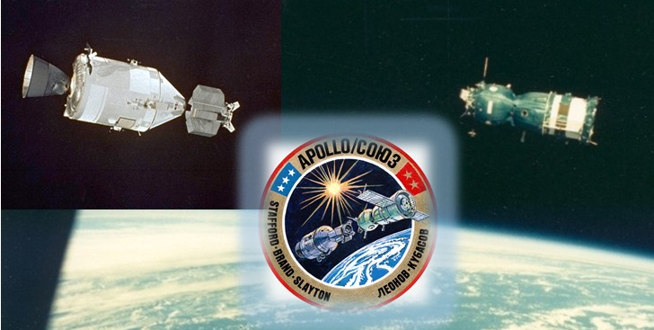
Figure 4.1 Docking of the crewed spacecraft Soyuz (USSR) and Apollo (USA). The alignment of rendezvous and docking, air-locking, communication and control systems was implemented.
Illustration – a collage of photos from NASA and TASS
The next steps in solving the problems of harmonizing the interfaces of SC and injection systems as well as orbital objects between each other were made in the eighties-nineties of the XX century.
The most significant achievements of those years were associated with implementation of two projects: the STS (Space Transportation System, USA), more known in the world as Space Shuttle, and the long-term operation orbital station MIR (USSR/RF).
With the emergence of the STS, which was originally conceived as a universal injection vehicle, the need for unification of technological solutions for the integration of injected objects with specific orbital-vehicle mechanical and electrical interfaces and the ground prelaunch operations support equipment became critical. The STS technical-and-economic efficiency indicators depended heavily on the solving of this problem. Especially bearing in mind the existing organizational and legal collisions in the commercial activities for rendering launch services to foreign companies-developers of payloads. And the problem was successfully solved.
The implementation of Space Shuttle missions with a multipurpose returnable research laboratory Spacelab (Figure 4.2) [13], including those for the SL-M (Spacelab–MIR) program, can serve as the most striking example.
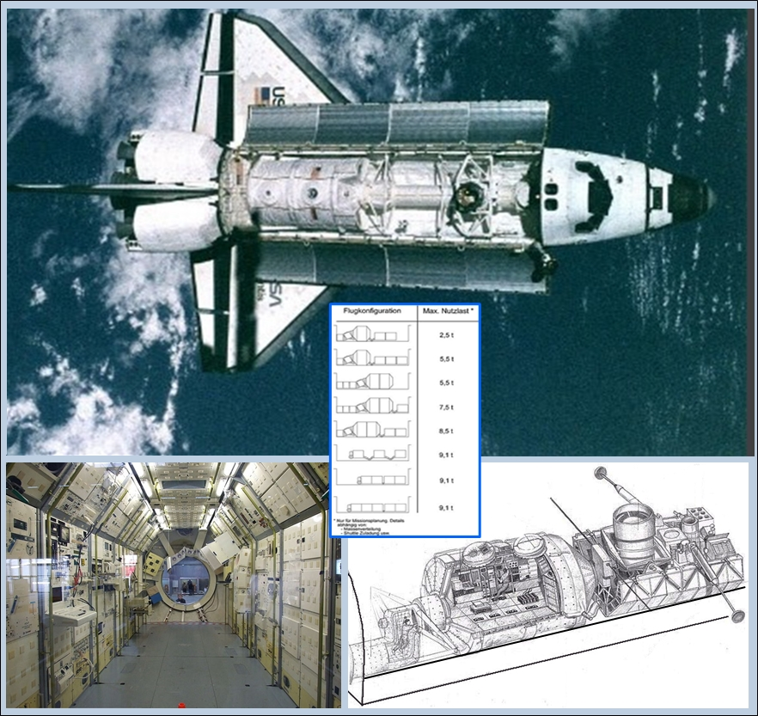
Figure 4.2 Research laboratory Spacelab. External view and schemes of arrangement of the laboratory in the Space Shuttle cargo bay, interior of the laboratory.
Illustrations from ESA, NASA, museum Bremennholle (Germany).
Spacelab, in the development of which, with assistance of the USA, took part European companies from 10 countries, was created in one crewed and many uncrewed configurations.
The lab was not unloaded from the cargo bay of the shuttle that delivered it to orbit, which allowed changing the composition and purpose of scientific equipment from flight to flight. At that, solutions were found and worked through for the compatibility of interfaces of life support systems, scientific and process equipment with regard to electrical power supply, heat removal, EMC, permissible mass and center-of-gravity characteristics, and bonding.
No less important experience was gained during the long-term (more than 14 years) operation of the station MIR in orbit. Interface compatibility problems for objects from different developers and nations were solved, including those within the nine joint Space Shuttle–Spacelab–MIR flights (Figure 4.3). In-orbit rendezvous and docking systems and docking assembly designs were improved, characteristics of delivered supply resources (water, food products, consumables) and their mass-size characteristics were unified.
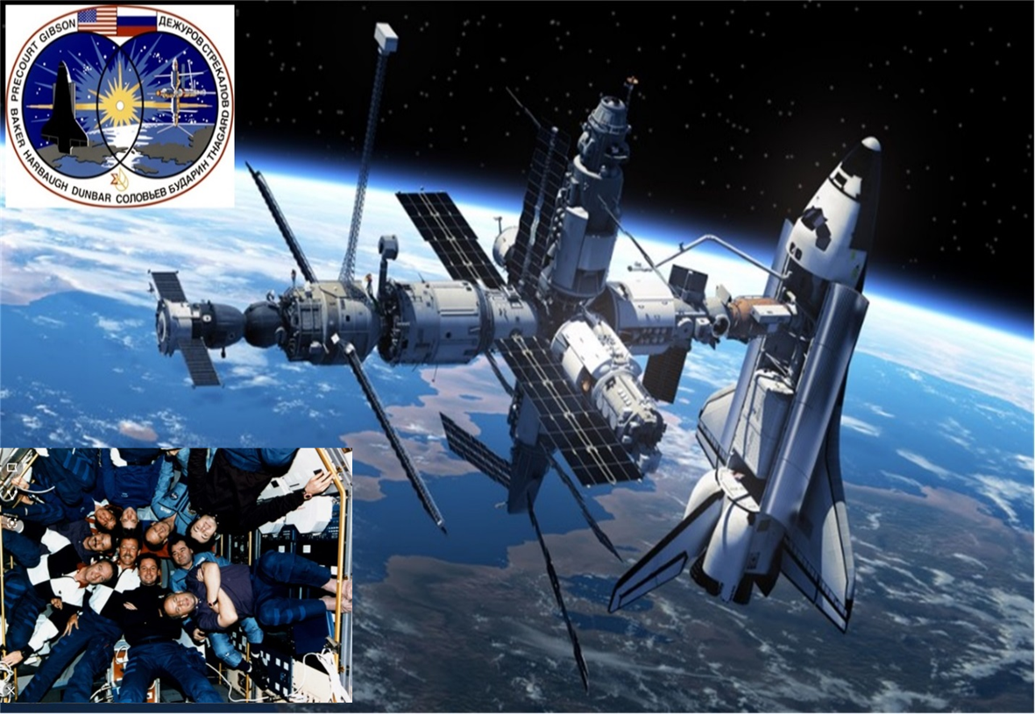
Figure 4.3 MIR Orbital station and Space Shuttle with Spacelab. Crew of the station and STS-71 expedition on board of Spacelab module. Technologies of aligning the interfaces of different-purpose crewed objects have been worked through
Illustrations from ITAR-TASS, NASA
In the variety of the many achievements in compatibility of interfaces of space facilities associated with implementation of the mentioned projects, there can also be marked out the creation of universal-in-interfaces robotic manipulators supporting extravehicular operations with different payloads, as well as working through the spacesuit interfaces compatibility (Figure 4.4).
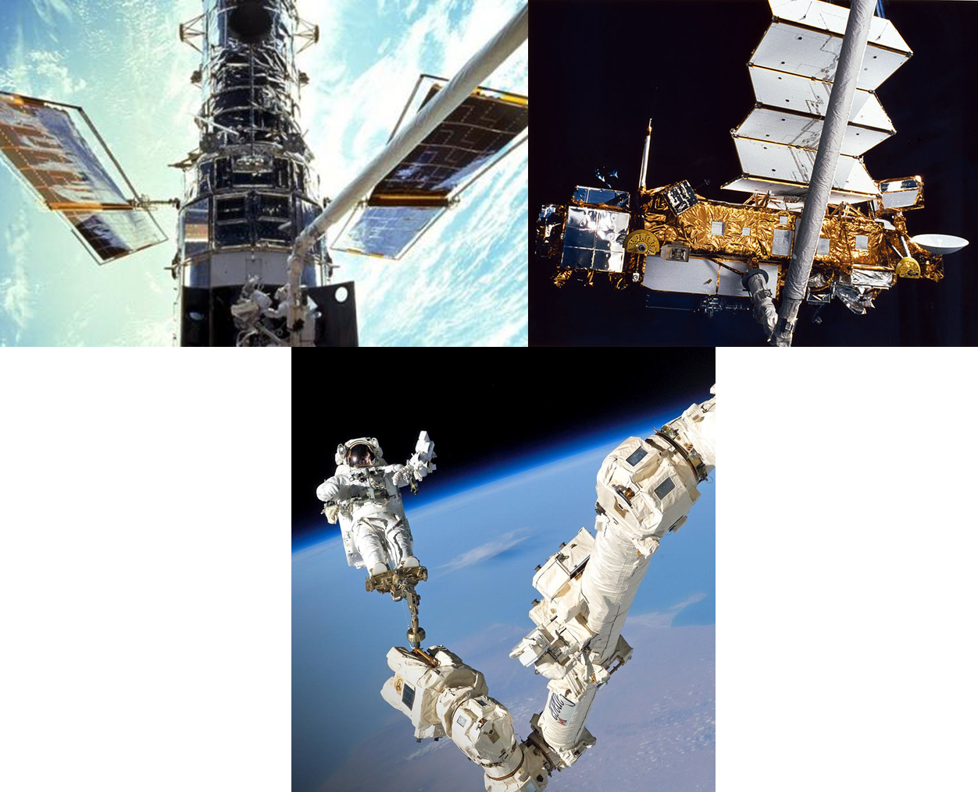
Figure 4.4 Using universal manipulators to handle payloads and support spacewalks (left – work with the Hubble telescope, right – with UARS spacecraft)
NASA’s illustration
On the whole, these projects have set precedents for technological solutions of space system interface compatibility problems, precedents of the procedures to solve legal issues arising in multilateral international cooperation when developing complex space objects, and thus made a strong practical foundation for the development, creation and operation of the first full-fledged In-space Systems of our time – International Space Station (ISS) (Figure 4.5).
It is impossible to overestimate the importance of the many years’ continuous functioning in near-Earth orbit of the multi-purpose crewed space research complex ISS in promoting ideas and concrete solutions in the space system interface compatibility area. A cooperation of 14 participating countries is involved in the sphere of scientific and technological experiments, servicing of stations, flight support, each country with its own cooperation of contracting parties, which was unthinkable just two decades ago. This is indicative of the achieved progress in compatibility of technical regulations, information exchange, standardization of technology development and verification procedures.
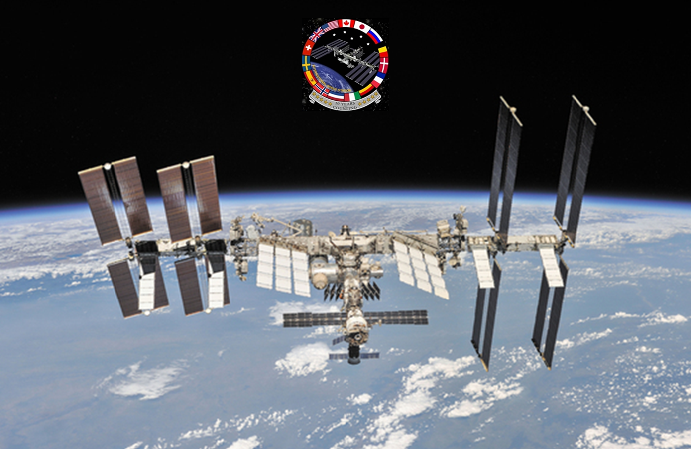
Figure 4.5 International Space Station. Present-day stage of progress in compatibility of interfaces of space systems.
Roscosmos’ illustration.
The most important achievement in the ISS project is the activity for compatibility of ground tracking organizational-managerial regulations and procedures. Thus two control centers are now directly involved in the ISS control: MCC-H (Houston) and MCC-M (Moscow suburb Korolyov). Moreover, each of them has a control sector backing up the opposite center – a sector at MCC-M to back up MСC-H and vice versa. In addition, the work of the ISS laboratory modules – the European Columbus and the Japanese Kibo – is controlled by Control Centers of the European Space Agency (Oberpfaffenhofen, Germany) and the Japan Aerospace Exploration Agency (Tsukuba, Japan), respectively, and the European automatic cargo vehicle ATV’s flights were controlled by the European Space Agency’s Center in Toulouse, France. This multilevel system have three times prevented an unforeseen development of situation, when, due to force majeure circumstances in Houston, the ISS control went completely to MCC-M.
Such a level of interchangeability has obviously been achieved through painstaking work on compatibility of communication facilities, data exchange protocols, compatibility of corresponding hardware devices, technological protocols.
The ISS’ second significant achievement setting a precedent for appropriate solutions for the Moon and lunar space exploration In-space Systems is the creation of necessary means and organizational schemes for crew rotation and uninterruptible support cargo traffics, taking into account the whole range of safety assurance matters. At present only the support cargo traffic is provided by five transport vehicles: Progress (RF), Cygnus and Dragon (USA), HTV (Japan), and ATV-5 (ESA). At that, Cygnus can be placed into orbit by both the launch vehicle Antares and launch vehicle Atlas-5, and Progress by any of the modifications Soyuz-U, Soyuz-FG, and Soyuz-2.1a.
A large part of the arriving volume of resources is unified in nomenclature, quality and size. Stringent regulations have been worked out and are maintained for determining the composition of cargos to be delivered, forming a specific mission, sequence of delivery. Solutions have been found to parry legal aspects and protect technologies.
Also it is relevant, in the general context of compatibility problems, to mention in detail the rapid development, with the formation and development of the market of commercial launch services, of the direction of integrating the SC interfaces with the traditional means of injection – launch vehicles. Whole systems of appropriate organizational and technical procedures to regulate the very process of such integration have been developed and are improved, involving a set of mandatory analyses and procedures, a verification system, and work is underway for their further standardization. The International Standard (IS) ISO 14303 Space systems – Launch-vehicle-to-spacecraft interfaces, mentioned in subsection 2.2.2.1, can serve as an example of such work.
The need of SC developers to have the ability to flexibly respond to offers of the market of injection vehicles, beginning from the design phase, has led to intensive generalization of the most successful implemented design solutions for mechanical and electrical interfaces of SC and launch vehicles. Thus a practice has formed at the beginning of the 2000s of using, besides separation bolt pyrotechnic devices, universal clamping band-type adapters and explosive rings of specific size types depending on the SC mass (Figure 4.6).

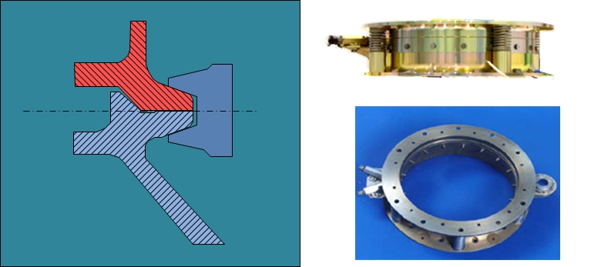
Figure 7.4 Typical devices for SC separation from the launch vehicle (clamping band-type adapter scheme and explosive ring adapter for microsatellites)
Characteristically, the launch vehicle developers of the countries that have recently joined the club of injection vehicle possessors – Japan, China, India, Italy – as well as a number of commercial companies, are already focusing on using the above mentioned typical adapters. Also, commercial offers have appeared of such adapters developed and tested by launching companies for SC developers and launch vehicle developers (including Yuzhnoye SDO).
It is more than an illustrative and live example of the positive effect of interface harmonization activities!
As we can see, the processes of harmonizing the interfaces of space systems for solving specific target tasks in the presence of political and/or commercial interests were going dynamically enough in the previous years, creating the basis for the further advancement in developing In-space Systems for exploration of the Moon, lunar space, and deep space.

4.2 Generalization of achieved results, current status
In 2016-2017, realizing the need to generalize the accumulated experience and overcome technical, organizational and political obstacles for involving of a wide international cooperation in the creation of future In-space Systems , the countries participating in the ISS project initiated the process of creating International Deep Space Interoperability Standards
Under the direction of the International Space Station (ISS) Multilateral Coordination Board (MCB), which includes representatives of NASA, Roscosmos, ESA, Canadian Space Agency, JAXA, the following standards/packages of standards were initiated in 2017 and are being developed:
- International Avionics System Interoperability Standards (IASIS);
- International Communication System Interoperability Standards (ICSIS);
- International Environmental Control and Life Support System (ECLSS) Interoperability Standards (IECLSSIS);
- International Space Power System Interoperability Standards (ISPSIS);
- International Rendezvous System Interoperability Standards (IRSIS);
- International Thermal Interoperability Standards (ITIS);
- International External Robotic Interoperability Standards (IERIS)
The draft packages are being updated, with the last two having taken into account remarks following the internal review at NASA and those made by some industrial developers. The latest release (C) was dated September 2018.
Each of these documents, without regarding specific hardware designs, defines a set of boundary conditions for functioning, performance and other characteristics for the above systems to be designed with their compatibility in mind.
These standards should, in effect, harmonize systems under development without unifying their designs.
This approach helps remove a great deal of technical obstacles in involving a wide international cooperation in created In-space Systems and their components.
The standards/packages of standards under development are based on the use of a set of fundamental international standards and normative documents of the participating countries, related to the direction being standardized.
Following are generalized tables of applicable and reference documents demonstrating this approach. The list may be of help for respective specialists.

Table 4.1 Documents underlying the International Avionics System Interoperability Standards (IASIS).
IEEE 802.3ab | – | 1000BASE-T Gbit/s Ethernet over twisted pair at 1 Gbit/s
SAE AS 6802 | – | Time-triggered Ethernet
ARINC 664-p7 | – | Avionics Full-Duplex Switched Ethernet
NASA/TM-2008-215108 | – | A Primer on Architectural Level Fault Tolerance
Table 4.2 Documents underlying the International Communication System Interoperability Standards (ICSIS).
REC SFCG 32-2R1 | – | Communication Frequency Allocations and Sharing in the Lunar Region
CCSDS 131.0-B-3 | – | TM Synchronization and Channel Coding
CCSDS 734.2-B-1 | – | Bundle Protocol Specification
CCSDS 734.1-B-1 | – | Licklider Transmission Protocol (LTP) for CCSDS
CCSDS 732.0.B-3 | – | AOS Space Data Link Protocol
CCSDS 401.0-B-26 | – | Radio Frequency and Modulation Systems – Part 1
CCSDS 727.0-B-4 | – | CCSDS File Delivery Protocol (CFDP) – Recommended Standard
CCSDS 735.1-B-1 | – | Asynchronous Message Service (AMS)
CCSDS 414.1-B-2 | – | Pseudo-Noise (PN) Ranging Systems
CCSDS 503.0-B-1 | – | Tracking Data Message
FIPS PUB 197 | – | Advanced Encryption Standard
NIST SP 800-38D | – | Recommendation for Block Cipher Modes of Operation Galois/Counter Mode (GCM) and GMAC
CCSDS 355.0-B-1 | – | Space Data Link Security Protocol
CCSDS 133.1-B-2 | – | Encapsulation Service
CCSDS 211.1-B-4 | – | Proximity-1 Space Link Protocol--Physical Layer
CCSDS 211.2-B-2 | – | Proximity-1 Space Link Protocol--Coding and Synchronization Sublayer
CCSDS 211.0-B-5 | – | Proximity-1 Space Link Protocol-Data Link Laye
CCSDS 301.0-B-4 | – | Time Code Formats
CCSDS 320.0-B-6 | – | CCSDS Global Spacecraft Identification Field Code Assignment Control Procedures
CCSDS 912.1-B-4 | – | Space Link Extension-- Space Link Extension--Forward CLTU Service Specification
CCSDS 911.1-B-4 | – | Space Link Extension--Return All Frames Service Specification
CCSDS 911.2-B-3 | – | Space Link Extension--Return Channel Frames Service Specification
CCSDS 922.1-B-1 | – | Cross Support Transfer Services--Monitored Data Service
CCSDS 506.1-B-1 | – | Delta-DOR Raw Data Exchange Format
CCSDS 881.0-M-1 | – | Spacecraft Onboard Interface Services – RFID Based Inventory Management Systems, Recommended Practice
RFC 791 | – | Internet Protocol
RFC 8200 | – | Internet Protocol version 6
CCSDS 766.2-B-1 | – | Voice and Audio Communications
ANSI S3.2 | – | Method For Measuring The Intelligibility Of Speech Over Communication Systems
ITU P.863 | – | Perceptual objective listening quality assessment
CCSDS 766.1-B-1 | – | Digital Motion Imagery
NASA STD-2822 | – | Still and Motion Imagery Metadata Standard
CCSDS 352.0-B-1 | – | CCSDS Cryptographic Algorithms
RFC 7242 | – | Delay-Tolerant Networking TCP Convergence Layer Protocol
RFC 793 | – | Transmission Control Protocol
450-SNUG | – | Space Network Users' Guide (SNUG)
DSN 820-100 | – | Deep Space Network Service Catalog
DSN 810-005 | – | DSN Telecommunications Link Design Handbook
453-NENUG | – | Near Earth Network Users Guide
CCSDS 506.0-M-1 | – | Delta-Differential One Way Ranging (Delta-DOR) Operations
CCSDS 901.1-M-1 | – | Space Communications Cross Support--Architecture Requirements Document
IOAG Service Catalog #2 | – | Interagency Operations Advisory Group Service Catalog #2
Table 4.3 Documents underlying the International Environmental Control and Life Support System (ECLSS) Interoperability Standards (IECLSSIS)
NASA-STD-3001, Vol. 2 | – | NASA Space Flight Human-System Standard, Vol. 2: Human Factors, Habitability, and Environmental Health
GOST Р 50804-95  Group D10 | – | State Standard of the Russian Federation Cosmonaut’s Habitable Environments on Board of Manned Spacecraft: General Medicotechnical Requirements (GOST)
ISO/DIS 16726, ISO/DIS  16157, ISO/DIS 17763 | – | Draft ISO Standards for Human-Medical Requirements
JSC 20584 | – | Spacecraft Maximum Allowable Concentrations for Airborne Contaminants
AIAA 2009-01-2592 | – | A Design Basis for Spacecraft Cabin Trace Contaminant Control
JSC 63414 | – | Spacecraft Water Exposure Guidelines

Table 4.4 Documents underlying the International Space Power System Interoperability Standards (ISPSIS);
MIL-STD-461 G | – | Requirements for the Control of Electromagnetic Interference Characteristics of Subsystems and Equipment
SAE AS5698 | – | Space Power Standard
Table 4.5 Documents underlying the International Rendezvous System Interoperability Standards (IRSIS)
IDSS IDD | – | International Docking System Standard (IDSS) Interface  Definition Document (IDD), Revision E, October 2016
DSG-16-32 | – | Rendezvous and Docking Standards Recommendation, ISS Exploration Capabilities Study Team – Rendezvous Standards Team, January 2017
SSP 30219 | – | Space Station Reference Coordinate Systems, Rev K, NASA International Space Station Program, July 2016
SSP 50808 | – | ISS to Commercial Orbital Transportation Services (COTS) Interface Requirements Document (IRD), Revision F, September 2014
SSP 50235 | – | Interface Definition Document for International Space Station Visiting Vehicles, International Space Station Program Office, February 2000
IDSS-GUIDE-001  редакция A | – | Navigation and Alignment Aids Concept of Operations and  Supplemental Design Information
Table 4.6 Documents underlying the International Thermal Interoperability Standards (ITIS).
SN-C-0005C, Rev. D | – | Contamination Control Requirements for the Space Shuttle Program
ASTM D1193 - 06(2011) | – | Standard Specification for Reagent Water
A-A-59150 (Rev. A) | – | CLEANING COMPOUND, SOLVENT, HYDROFLUOROETHER (HFE)
SSP 30245, REV. E | – | Space station electrical bonding requirements
MIL-PRF-27401F | – | Propellant pressurizing agent, nitrogen
CGA G-10.1 | – | Commodity specification for nitrogen
MIL-STD-1246, REV. C | – | Military standard product cleanliness levels and contamination control program
SSP 30573, REV. F | – | SPACE STATION PROGRAM FLUID PROCUREMENT AND USE CONTROL SPECIFICATION
IEST-STD-CC1246E | – | PRODUCT CLEANLINESS LEVELS – APPLICATIONS, REQUIREMENTS, AND DETERMINATION
NASA-STD-6016A | – | STANDARD MATERIALS AND PROCESSES REQUIREMENTS FOR SPACECRAFT
IECLSSIS | – | INTERNATIONAL ENVIRONMENTAL CONTROL AND LIFE  SUPPORT SYSTEM (ECLSS) INTEROPERABILITY STANDARDS
SLS-SPEC-159, REV. D | – | Cross program design specification for natural environments (DSNE)
IERIS | – | International external robotic interoperability standards (IERIS)
SSP-41172, REV. AD | – | Qualification and acceptance environmental test requirements
SSP 57000, Rev. R | – | Pressurized payloads interface requirements document
Table 4.7 Documents underlying the International External Robotic Interoperability Standards (IERIS).
IASIS | – | International Avionics Systems Interoperability Standards
ICSIS | – | International Communication System Interoperability Standards
ISPSIS | – | International Space Power System Interoperability Standards
ITSIS | – | International Thermal System Interoperability Standards
SLS-SPEC-159 | – | Crossprogram Design Specification for Natural Environments (DSNE)
SLS-ESD 30000 | – | SLS Mission Planners Guide
IDSS IDD | – | International Docking System Standard (IDSS) Interface Definition Document (IDD), Revision E, Oct. 2016
ISO 9409-1 | – | Manipulating industrial robots - Mechanical interfaces – Part 1: Plates
It should be noted that these standards/packages of standards are being created mainly for the Deep Space Gateway and Transport (DSG&T) concept, but the work goes beyond and is an actual example of international cooperation for future developments of In-space Systems.

4.3 perspective directions of work on interfaces compatibility for establishment of future IN-SPACE SYSTEMS
The activity discussed in the preceding subsection (4.2) indicates that the promising directions of work on harmonization of interfaces for newly created In-space Systems objects in the DSG&T concept have basically been determined by the international community of the countries participating in the ISS.
From the content of the draft standards/packages of standards themselves it is not difficult to conclude that they are all designed to solve a substantial part of the general range of harmonization problems outlined herein in sections 2 and 3.
Thus, absolutely coinciding are the following directions:
- Compatibility of components interaction interfaces (draft standards IASIS, IECLSSIS, IRSIS, ITIS, IERIS);
- Compatibility of information exchange facilities interfaces (draft standard ICSIS).
Also, all these draft standards cover the interface compatibility problems of support cargo traffic facilities.
Partially addressed are the problems of:
- Compatibility of interaction interfaces of In-Space Systems of different developers;
- Characteristics of support cargo traffic components (water, food products, compressed gases, etc.);
- Compatibility of survivability and safety support facilities.
The MVA, stressing the efficiency of the approach demonstrated by ISS participants, can initiate/propose the creation of similar draft packages of standards for a number of directions associated with Moon exploration. Following are some of the proposals that are relevant enough for developers:
а) Package of standards for compatibility of navigation facilities on the Moon’s surface and in the near lunar space – to ensure the landing accuracy of lunar landers and track the movement of lunar equipment and personnel of lunar bases;
b) Package of standards for compatibility of surface work spacesuits’ design and architecture of their equipment, servicing, repair. Compatibility of overall dimensions, air-locking procedures;
c) Widening of the range of issues addressed by the external robotic interoperability standards (IERIS), or creation of a separate package for compatibility of robotic mechanisms that will be used on the Moon. First of all lifting mechanisms unloading payloads delivered by lunar landers and those used on lunar rovers. Currently the draft IERIS standards are mainly concerned with orbital mechanisms;
d) Package of standards for compatibility of heavy crewed lunar rovers’ crew operation support equipment, in particular spacesuits, onboard communication and navigation equipment, interchangeability of movers (wheels, augers, etc.), power sources, battery charge interfaces, maintainability and compatibility with universal tools, etc.;
g) Standard for mechanical and electrical interfaces that integrate PLs delivered to the Moon (modules, rovers, packages of cargo) and lunar landers.
It also seems reasonable to focus on the generalization of the technologies and tools used for repairs made outside habitable modules, based on the experience of the ISS multi-year operation, orbital flights of Space Shuttle, Spacelab, MIR. This experience should be timely comprehended and implemented in developments of In-space Systems components for Moon and lunar space exploration.
Note. These proposals are given to illustrate the possibilities of work continuation and do not exhaust the whole spectrum of the problems.
It is important to note that the benefits from works in these directions will be really tangible if developers of alternative In-space Systems. i.e. concepts other than DSG&T, adhere to the worked out standards. Say, developers of the RF and/or PRC, private companies, when creating their own lunar base or circumlunar objects, will adhere to the standards worked out for DSG&T. Today its not proven that it is going to be the case, and there can actually be a negative situation when components developed for a Russian or Chines lunar base or circumlunar group will be incompatible with DSG&T components.
Despite the significant progress in the interface compatibility area demonstrated by creating packages of standards already being developed and offered, there are certain problems unlikely to be solved in the framework of the approaches adopted by ISS participants. Following are some of them, mentioned in section 3.2:
– Compatibility of interfaces of payloads and injection systems (landers and modules with SHLISs from not their own cooperation pool of developers);
– Creation of joint safety support architecture for In-space Systems operating in parallel through diversification and stability of support cargo traffic.
Such and other problems of similar complexity can only be solved through development of truly global projects of Moon and lunar space exploration.
It is obvious that in this case it is necessary to overcome not only technical obstacles but also those listed in subsection 2.2.1 (political and legal, national, corporate). In its turn it cannot be done without strengthening the international cooperation, creating an atmosphere of trust and the appropriate legal base unequivocally accepted by the international community.
We will not get out of touch with the present-day global realities.
The interests of the Earth civilization in space, about which in an abstract philosophical sense spoke distinguished scientist Konstantin Tsiolkovsky (whose words have been put in the epigraph of this report [14] ), or the futuristic, once very popular constructions of astrophysicist Freeman Dyson (Dyson Sphere) [15], science-fiction writers Isaac Asimov, Arthur Clarke [16, 17] and other cosmists, are still giving way to more down-to-earth interests:
– To strengthen the own positions in the world, having converted the national leadership in space to the real earthly capital (through dozens of existing ways – from the direct advertising of products to the pumping-up of stock exchange ratings);
– To give a progressive character to the own economy through advanced space technology achievements;
– To gain access to an additional resource base – energy, minerals;
– To get advantages in the sphere of scientific discoveries, double-purpose technologies;
– To use the Moon and lunar space for tourism and travelling;
– To satisfy the need of a certain part of society to experience in practice the spirit of adventurous colonization of the previous centuries.
Admitting that such interests also, in some of their components, promote the progress on the way of the Moon and deep space exploration and the UN-declared principles of sustainable development, we will take the liberty to say that the potentials of combining efforts, including those for harmonization of interfaces, are immeasurably wider.
They can be opened up in full only with the solving of purely earthly problems, first of all eliminating the threats of the global economic and military confrontation of countries and closed military-political blocs, eliminating the threats of turning space into a new arena of arms race and confrontations in the spirit of the mid-twentieth century cold war. And such a threat is more than real, to which MVA member Dennis O'Brien drew attention in his report at the 8th CSA-IAA Conference on Advanced Space Technology [18]. In the same report it was said that the existing international institutions, including such important as the UN Committee on Peaceful Uses of Outer Space (COPUOS), have not created an internationally-accepted legal base to support the development of activities on the Moon and in outer space [19].
Qualitatively different efforts are necessary.
The Moon and lunar space exploration task should stop to be a way of satisfying the egocentric interests of the space race leaders and their pools of cooperation, but become a common task for all the people of Earth. That is the motives of national prestige should go to the background before the common tasks of humanity.
Has time come for such a virtually tectonic shift – to take the advance from near-Earth orbits to the Moon, Mars, and into deep space as a task of the Earth civilization in whole and make proper technical and legal decisions?
We have to state – there are not sufficient prerequisites for the positive answer.
Nonetheless, let us outline a futuristic positive scenario:
– SHLISs, interorbital tugs and ground launch infrastructure are common at the international level with a properly and optimally selected launch point;
– lunar In-space Systems (including landers, lunar base modules, circumlunar communication and navigation infrastructure components, an orbital station) to the mutually complementary and compatible architecture and design coordinated at the international level;
– The structure of vehicles providing cargo traffic is established according to the mutually complementary scheme based on national heavy-lift transportation vehicles; (other than SHLISs);
– A unified international scheme for In-space Systems control and tracking, cargo traffic, crew delivery and return is created;
– In-space Systems deployment is preceded by a program of automatic exploration missions.With such development of events, there would be place for participation of both the leading countries and those who takes the first steps in the field of space programs. The multibillion costs to be incurred would concentrate in one program instead of at least three identic-in-purpose programs of the USA, RF and PRC similar in the volume of costs for implementation.
Is this scenario too fantastic ?
Not at all. Humanity has already implemented a project of similar complexity. It exists and works, though in a different area. This is the Large Hadron Collider at CERN (European Organization for Nuclear Research) – the largest in the world experimental installation of about 10 billion US $, in whose creation took part more than 100 countries and about 10 thousand scientists [20].
This is more than an inspiring example for uniting efforts in development of space technologies!

Summary
By the present time, humanity has created real technical prerequisites to start a new phase of development – exploration of extraterrestrial energy and raw material resources, expansion of the human habitation sphere to objects nearest to the Earth, first of all the Moon, and in the foreseeable future Mars and other objects of the Solar system.
Realization of such possibilities is linked with a philosophical and humanitarian compromise between the need to solve vital terrestrial problems (to eliminate the threat of a new world war, to overcome disproportions in the development of countries, poverty and famine, to save the environment, etc.) and diversion of considerable means and resources for new steps in space. According to estimates, the amounts of diverted means should be comparable to annual budgets of large countries.
The finding of acceptable solutions can be eased by searching for ways of substantial cost reduction without harm for assigned ambitious goals. This technical report proposes and analyzes one of the available methods – maximal harmonization, compatibility of interfaces of objects and facilities created for exploration of lunar space, the Moon, and, in the long term, deep space.
Such key objects will be extraterrestrial long-term operation space complexes with specific properties distinguishing them from all the other space systems.
Deploying In-space Systems and satisfying resource replenishment and crew rotation needs requires heavy- and super heavy-lift injection systems with capability of performing two-three launches a year. The objects will be formed on a step-by-step basis, with their configuration being transformed from initial vanguard components to full-fledged complexes. Their dependence on supplies and remote support from Earth will last throughout the decades of their operation. They will include target components, modules, with different degrees of interdependence – from full autonomy to inability to function separately from the object in whole. Due to their high cost, In-space Systems and ground support structures will be created via international cooperation.
An analysis of the listed features has enabled to mark out the directions of activities for harmonization/compatibility of In-space Systems interfaces potentially reducing the general costs for their creation. Among them is harmonizing the interfaces of:
– Payload and injection systems;
– In-space Systems components harmonization;
– Harmonization of In-space Systems of different developers;
– Information exchange and support cargo traffic facilities;
– Survivability and safety support facilities.
Also, two blocks of factors impeding progress in the listed directions have been revealed and analyzed:
– Political and legal international, national, corporate;
– Technical.
The division into blocks is relative, because all the impeding factors are intertwining and overlapping each other. Thus, on the one hand, the uniqueness of super heavy-lift injection vehicles created as national projects of the USA, and in foreseeable future the RF and PRC, determines limitations for the configuration of future In-space Systems (through energy and other features of SHLISs, as well as ground launch infrastructure features). On the other hand, the national character of the developments, due to political and legal restrictions, narrows the possibility of expanding the circle of partners-developers of In-space Systems modules, restricting them to their own closed pool. This results in parallel creation of several In-space Systems projects with target tasks of the same type, multiplying their ultimate cost for humanity. With that, the potential of harmonizing the interaction of components of In-space Systems of different developers remains almost uncalled for, and mutually complementary architecture of the facilities providing cargo traffic to support their operation is not created. From the brief review of the current state of SHLIS and In-space Systems developments given in this report, it follows, in terms of using the potential of interfaces harmonization/compatibility, that this potential is used minimally and not systematically. Factors hindering this prevail, such as in the direction of compatibility of payload and injection system interfaces for future In-space Systems components.
The most noticeable progress of international and corporate collaboration for interfaces harmonization is taking place in the directions of compatibility of information exchange facilities’ interfaces and In-space Systems components interaction interfaces (within a single pool of developers).
Also, in historical retrospective, it can be stated that considerable experience has been gained in solving compatibility problems for interfaces of different purpose space systems. From that whole extensive field connected with launch services and the historic Soyuz-Apollo mission to the systematic current ISS creation and operation activities.
The most meaningful and important for solving interface compatibility problems when creating In-space Systems is the experience of Space Transportation System (Space Shuttle) flights with the research laboratory Spacelab, including those for the SL-M (Spacelab–MIR) program, the more than 14 years of operation of the orbital MIR station, and, of course, the creation and operation of the ISS – the only active cislunar object, which can be rightly referred to as In-space Systems.
To generalize the accumulated experience, and for the purpose of overcoming technical, organizational and political obstacles for the involvement a wide international cooperation in the creation of future In-space Systems, under the direction of the International Space Station (ISS) Multilateral Coordination Board (MCB), which includes representatives of NASA, Roscosmos, ESA, Canadian Space Agency, JAXA, development of the following international deep space interoperability standards/packages of standards was initiated in 2017 and is carried on:
- International Avionics System Interoperability Standards (IASIS);
- International Communication System Interoperability Standards (ICSIS);
- International Environmental Control and Life Support System (ECLSS) Interoperability Standards (IECLSSIS);
- International Space Power System Interoperability Standards (ISPSIS);
- International Rendezvous System Interoperability Standards (IRSIS);
- International Thermal Interoperability Standards (ITIS);
- International External Robotic Interoperability Standards (IERIS).
An efficient principle has been found for the development of these standards/packages of standards. Its essence is that, without regarding specific hardware designs for the above systems, a set of boundary conditions for functioning, performance and other characteristics is defined for them to be designed with their compatibility in mind. This approach helps remove a great deal of obstacles in involving a wide international cooperation in the development of In-space Systems and their components.
The works are being carried out to support the development of In-space Systems in the Deep Space Gateway and Transport conception, the groundwork of which should be laid by creating a circumlunar orbital station – Lunar Orbital Platform-Gateway (LOP-G)
Emphasizing the efficiency of the approach adopted by ISS participants, striving for its development, it is proposed in this report to create similar draft packages of international standards for In-space Systems and their components designed for Moon exploration, namely for:
а) Compatibility of navigation facilities on the Moon’s surface and in the near lunar space;
b) Compatibility of lunar surface work spacesuits’ design, architecture, equipment, servicing, repair. Compatibility of air-locking procedures;
c) Compatibility of robotic mechanisms that will be used on the Moon (lifting mechanisms for unloading payloads delivered by lunar landers, and those used on lunar rovers);
d) Compatibility of heavy crewed lunar rovers’ crew operation support equipment, in particular spacesuits, onboard communication and navigation equipment, interchangeability of movers (wheels, augers, etc.), power sources, battery charge interfaces, maintainability and compatibility with universal tools, etc.;
g) Standard for mechanical and electrical interfaces integrating PLs delivered to the Moon (modules, rovers, packages of cargo) and lunar landers.
A separate direction in the activity can be the generalization, in terms of interface compatibility, of the technologies and tools employed for repairs made outside habitable modules, the experience of ISS operation, orbital flights of Space Shuttle, Spacelab, MIR.
Despite the significant progress in achieving interface compatibility goals for future In-space Systems demonstrated by the work for creating packages of international standards that are already being developed and offered, it seems that the approaches adopted by ISS participants cannot open up the existing potential to the full extent. In particular, they do not cover the problems associated with solving the issues of compatibility of payloads (landers and modules) interfaces with SHLISs of not their own pool of developers, creation of joint safety support architecture for In-space Systems operating in parallel through support cargo traffic diversification and stability, etc. Moreover, the benefits from the work being done will be really tangible if developers of alternative In-space Systems conceptions (in the RF and PRC) other than DSG&T adhere to the worked out standards, which is not the case.
The further progress is possible with coming to a principally new level of international cooperation, which cannot be reached without significantly enhancing the general atmosphere of confidence in the world, eliminating the threats of turning space into an arena of a new arms race and confrontations in the spirit of the mid-twentieth century cold war, removing political and normative barriers and limitations.
Only in this case there can be created legal regulation mechanisms unequivocally accepted by the international community that will foster the space expansion of humanity. The Moon and lunar space exploration task should stop to be a way of satisfying the egocentric interests of the space race leaders and their pools of cooperation, but become a common task for all the people of Earth. Leaning on the UN-declared principles of sustainable development and the existing precedent of the collective international solving of a most complex scientific-technical, organizational, legal and financial (!) task – creation of the Large Hadron Collider, an adequate positive futuristic scenario is outlined in the report.
It seems that realization of the proposed scenario can allow a long-run and progressive advancement towards the Moon and Mars at reasonable saving of resource, owing to, among other things, harmonization of the interfaces of SHLISs and In-space Systems being created.

RESUME OF THE REPORT
In addition to the Summary of the Report key outcomes of activities on Conceptual Analysis of In-Space Systems’ Interfaces Harmonization Directions for the Moon Exploration are provided below.
1. Main objective and advantages of interfaces` harmonization are outlined.
2. Directions of interfaces` harmonization are specified.
3. Obstacles of interfaces` harmonization are listed and described.
4. Range of unified systems and components are proposed.
5. Analysis of existing and perspective developments of In-space Systems is performed.
6. It is stated that interfaces` harmonization is implemented minimally.
7. Success-stories and practical achievements in this area are described.
8. Existing standards covering interfaces` harmonization issue are systemized.
9. International standards under development are listed.
10. Perspective directions of activities on interfaces` compatibility are provided.
11. Top-priorities of technical areas for harmonization were identified.
12. Practical recommendations are elaborated.
13. The perfect scenario of In-Space Systems sustainable deployment is presented.
14. Benefits of interfaces` harmonization are outlined.
Moreover, the following benefits of interfaces harmonization were determined specifically:
1. Cost saving.
For now significant experience of space systems interfaces` harmonization has been accumulated. Practice of space activities demonstrates that interfaces` harmonization facilitates decrease of launch services prices as well as expenses for long-term in-space complex systems operation. It won’t be possible to implement such a global project as International Space Station. Maximum harmonization, compatibility of technical systems and objects, developed to expand human exploration of the Moon and Mars – are correct approach and practical method to decrease significantly, potentially in several times, overall expenses required to achieve ambitious goals.
2. Additional opportunities for industry players.
In-space systems interfaces harmonization can potentially lead to practical benefits to private industry players providing access to broad space technology and making private industry development activities more efficient and simple.
The further progress is possible with coming to a principally new level of international cooperation, which cannot be reached without significantly enhancing general atmosphere of confidence in the world. Therefore, interfaces` harmonization will create background for In-space Systems international space community.
3. Sharing benefits of the exploration.
Interfaces` harmonization will make possible sharing benefits of the exploration and use of outer space with various countries irrespective of their degree of economic or scientific development. This will form a common architecture available to world community. Technologically-advanced countries can share their technologies and encourage progress of other market players.
Recommendations for MVA:
MVA can become a platform for the dialog at the international level of the issues highlighted in this Report, systematization of developments and achievements and an instrument for promotion of required initiatives.
1. MVA can attract attention of international community, including governmental and commercial In-Space Systems developers and operators, to the interfaces` harmonization issue.
2. MVA can facilitate determination of the most efficient and top-priority directions of interfaces compatibility in terms of cost saving for the systems to be developed as well as obstacles overcoming methods.
3. MVA can facilitate development of international interaction mechanisms, discussions and decision-making on this topic through existing non-governmental organizations, international communities, etc.
4. MVA can facilitate resolution of technical issues of interfaces` compatibility of In-Space Systems under development through support of relevant international standards packages for a number of directions associated with the Moon exploration.

REFERENCE MATERIALS AND DOCUMENTS
To Introduction
1 | – | Agenda 21” Declaration accepted at the United Nations Conference on Environment and Development (June 1992, Rio de Janeiro).
2 | – | Documents of the World Summit on Sustainable Development (September 2002, Johannesburg).
To section 2
3 | – | Internet resource http://www.thespacereview.com/article/1579/1
4 | – | Internet resource https://www.rbc.ru/society/06/04/2011/5703e5c19a79473c0df1c7e6
5 | – | Internet resource http://www.thespacereview.com/article/1579/1 ; https://iz.ru/news/548379
6 | – | Internet resource https://ria.ru/20190209/1550624484.html
7 | – | Internet resource https://avianews.info/raketa-nositel-chanchzhen-9-poletit-v-2030-godu-i-klyuchevye-tehnologii-dlef-etogo-uzhe-est/
To section 3
8 | – | Internet resource https://globalspaceexpoloration.org/?p=774  GER_2018_small_mobile.pdf
9 | – | Internet resource http://www.nasa.gov/moon;  (sites/default/files/thumbnails/image/gat configuration-20180705.jpg)  en.m.wikipedia.org/wiki/Lunar_Gateway
10 | – | Internet resource REGNUM https://regnum.ru/news/2569444.html
11 | – | Internet resource https://cndc.com/2018/11/29/nasa-picks-9-companies-to-compete-for-lunar-transportation-contracts.html
To section 4
11 | – | Internet resource en.m.wikipedia.org/wiki/Apollo
12 | – | Internet resource en.wikipedia.org/wiki/File:German_SpaceLab_03.jpg  http://www.buran.ru/htm/shutle.htm  https://geektimes.ru/post/211891  https://ria.ru/spravka/20160721/1472409900.html
13 | – | Циолковский, К. Э. Избранные труды. – М., 1962. – С. 196. (Tsiolkovsky, K. E. Selected works. – Moscow, 1962. (Ibid. – P. 196).
14 | – | Internet resource https://ru.wikipedia.org/wiki/Дайсон,_Фримен
15 | – | Internet resource https://ru.wikipedia.org/wiki/Азимов,_Айзек
16 | – | Internet resource https://ru.wikipedia.org/wiki/Кларк,_Артур_Чарльз
17 | – | Dennis O'Brien, Report at the 8th CSA-IAA Conference on Advanced Space Technology: "Futher steps: Agreement on adoption of Moon treaty", section 18 "Pretentions and nationalism"
18 | – | Dennis O'Brien, Report at the 8th CSA-IAA Conference on Advanced Space Technology: "Futher steps: Agreement on adoption of Moon treaty", section 17 "Adaptive control"
19 | – | https://ru.wikipedia.org/wiki/Большой_адронный_коллайдер
Other materials and sources used in preparation of the report
International Avionics System Interoperability Standards (IASIS)
Draft C – February 2018
International Communication System Interoperability Standards (ICSIS)
Draft C – February 2018
International Environmental Control and Life Support System (ECLSS) Interoperability Standards (IECLSSIS)
Draft C – February 2018
International Space Power System Interoperability Standards (ISPSIS)
Draft C – February 2018
International Rendezvous System Interoperability Standards (IRSIS)
Draft C – February 2018
International External Robotic Interoperability Standards (IERIS)
Draft C – February 2018
International Thermal Interoperability Standards (ITIS)
Draft C – February 2018
Циолковский, К. Э. Избранные труды. – М., 1962. – С. 196. (Tsiolkovsky, K. E. Selected works. – Moscow, 1962. (Ibid. – P. 196).
Сэм Хоу Верховек. Материал National Geographik _Россия
«Космическая экспансия – новая эра космических полетов», 07.08.2019г
nat-geo.ru/sience/universe/kosmicheskaya-ekspansiya-novaya-era-kosmicheskih-poletov
В.В.Казютинский, Доклад на научных чтениях памяти К.Э.Циолковского, 2008г. секция «Космонавтика и общество: философия К.Э.Циолковского»
От космической философии – к философии космонавтики
(V.V. Kazyutinskiy, Report at Scientific Readings in memory of K.E. Tsiolkovsky, 2008, Cosmonautics and Society section: Philosophy of K.E. Tsiolkovsky)
Попов Е. И. Системы автоматических космических аппаратов
(E.I. Popov. Systems of automated spacecraft)
В.В.Горовцов, Доклад на научных чтениях памяти К.Э.Циолковского, 2015г. Совершенствование устройств систем разделения космических аппаратов
(V.V. Gorovtsov, Report at Scientific Readings in memory of K.E. Tsiolkovsky, 2015. Improvement of devices of spacecraft separation systems)
Aerospace Safety Advisory Panel Annual Report for 2018,
National Aeronautics and Space Administration, Washington, DC 20546
Dr. Patricia Sanders, Chair January 1, 2019
Лунный договор http://www.unoosa.org/oosa/en/ourwork/spacelaw/treaties.html
Сайт комитета ООН по использованию космического пространства в мирных целях (COPUOS). http://www.unoosa.org/
http:/www.nasa.gov
http:/www.nasa.gov/moon, в частности:
NASA's Exploration Campaing: Back to the Moon and on to Mars
https://www.nasa.gov/feature/nasa-outlines-new-lunar-science-human exploration-missions ; (/sites/default/files/thumbnails/image/gat configuration-20180705.jpg);
(/sites/default/files/thumbnails/image/nasa- exploration-campaign.jpg)
Site «Roscosmos» http://www.roscocmos.ru
Material: www.roscocmos.ru/202/ МКС и другие
International Organization for Standards (ISO)
https://www.iso.org/home.html
Site Moon Village Association Working Groups. https://moonvillageassociation.org/about/working-groups
Wiki.org.ru /Андрогинно-переферийный агрегат стыковки – АПАС-95
Wiki.org.ru / NASA Djcking System (NDS)
By Loren Grush, 14.02.2019г. NASA wants to jump-start development of landers to take humans to the Moon. Speed is of the essence
https://www.theverge.com/2017/7/12/15958164/moon-express-robot-landers-private-mining-outpost
https://www.theverge.com/2017/9/29/16378802/elon-musk-mars-plan-rocket-spaceship-colonization-iac-2017

